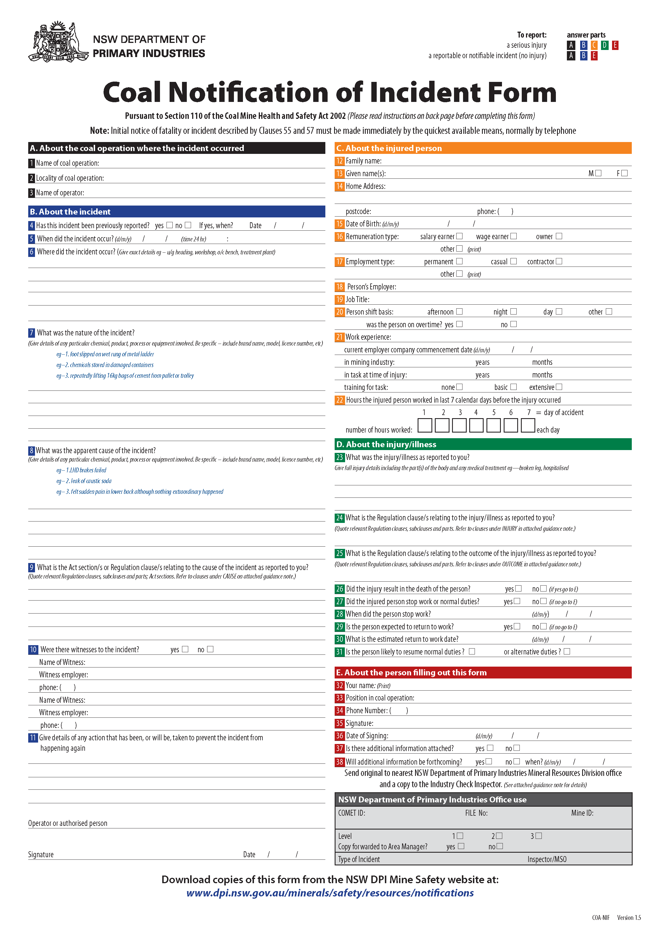

NSW DPI Coal Incident Form

A form must be sent to NSW DPI if there is an incident prescribed by the Coal Mine Health and Safety Act 2002 (the Act) and Regulation 2006 (the Regulation) at a mine. Please consider the Act and Regulation and the following dot points when completing and sending the form:
- You are required by law to send an incident form to NSW DPI for work-related incidents. The prescribed incidents are identified in the following tables.
- Where an incident is reportable under multiple clauses, each clause is to be referenced on the notification.
- You must keep a copy of any incident form that you send to NSW DPI for at least 5 years.
- You must send the form to your nearest regional NSW DPI Mineral Resources office.
- You can e-mail the form to the address below. You must still send the original form unless you attach a digital signature of an authorised person.
- You may send additional information with the form including sketches, photos, plans, etc.
- Preliminary telephone advice will assist classification and prompt response.
- It is expected 7-day limit items will be reported during the next working day after becoming aware of incident.

Note about the Clauses on this Guidance Note: The notifiable Clauses listed below are not in the same order as in the Act or Regulation. To help you complete the form, they are instead grouped by Incident Cause, Nature of Injury and Outcome of injury or illness.

COAL OPERATIONS (see below for Coal Exploration Sites)

Q9. Cause – CMHSR 2006 requirements to notify the cause of an incident
Regulation Clause Number | Clause | Notification Period | Non Disturbance Period
55 (c) | any of the following events or circumstances that present an immediate threat to life or of permanent incapacitating injury:  (i) damage to any plant, building or structure,  (ii) imminent risk of explosion or fire,  (iv) failure of strata, or of slope stability control measures,  (vi) the unintended activation or movement of vehicles or machinery | Immediate | 24 hours
55 (d) | any incident involving electricity:  (i) as a consequence of which a person suffers injury, receives treatment from a health care professional or is unable (on medical advice) to attend work for any period of time, or  (ii) where a vehicle, machinery or other plant makes contact with an energised high voltage source involving a risk to any person | Immediate | 24 hours
55 (e) | an uncontrolled explosion or fire or a misfire of explosives in the underground parts of a coal operation | Immediate | 24 hours
55 (f) | an uncontrolled outburst of gas | Immediate | 24 hours
55 (g) | an abnormal inrush of fluid | Immediate | 24 hours
55 (h) | a collision on the surface part of the coal operation involving a vehicle or mobile plant with a gross weight of more than 2 tonnes | Immediate | 24 hours
55 (i) | the loss of control of a heavy vehicle or other large plant on the surface part of the coal operation | Immediate | 24 hours
55 (j) | the overturning of a heavy vehicle or other large plant on the surface part of the coal operation | Immediate | 24 hours
55 (k) | ejection of fly rock so that it falls outside a blast exclusion zone (that is an area from which persons are excluded during blasting) or near people | Immediate | 24 hours
55 (l) | failure of any part of a powered winding system or damage to a shaft or shaft equipment | Immediate | 24 hours
56 (1) (d) | a spill or incident resulting in exposure or potential exposure of a person to a notifiable carcinogenic substance or a prohibited carcinogenic substance | 24 hours | n/a
56 (1) (e) | contact of a person with an energised electrical item that is supplied at above extra low voltage | 24 hours | n/a
56 (1) (f) | initial self-heating of coal or other material, or any heating of coal in the underground parts of a coal operation that results in withdrawal of people | 24 hours | n/a
56 (1) (g) | an accumulation of gas that requires the withdrawal of people or results in the tripping off of electric power | 24 hours | n/a
56 (1) (h) | an unplanned fall of a roof or sides that impedes passage or disrupts mine ventilation or extends outside the bolted zone | 24 hours | n/a
56 (1) (i) | A windblast that results in injuries requiring treatment by a medical practitioner | 24 hours | n/a
56 (1) (j) | the burial of machinery such that it cannot be recovered under its own tractive effort | 24 hours | n/a
56 (1) (k) | A creep or progressive pillar collapse | 24 hours | n/a
56 (1) (l) | an event that occurs in a hazardous zone in the underground parts of the coal operation and from which an electric arc is observed or that leaves visible evidence on an electric cable of arcing having occurred | As soon as  practicable,  no later than  7 days | n/a
56 (1) (m) | the in-service failure of the explosion-protection characteristics of explosion-protected plant | As soon as  practicable,  no later than  7 days | n/a
56 (1) (n) | an uncontrolled explosion or fire or a misfire of explosives in the surface parts of a coal operation | 24 hours | n/a
56 (1) (o) | an escape of fluid under pressure that could place any person at risk | 24 hours | n/a
56 (1) (p) | an unintended activation or movement of vehicles or machinery that does not present an immediate threat to life or of permanent incapacitating injury | As soon as  practicable,  no later than  7 days | n/a
56 (1) (q) | A sudden pillar collapse | 24 hours | n/a
For a notifiable injury or outcome with no notifiable incident cause, write “Non-Specific” at Question 9.
Q24. Injury – CMHSR 2006 requirements to notify the Nature of Injury
Regulation Clause Number | Clause | Notification Period | Non Disturbance Period
55 (a) | an injury to a person that results (at any time after the injury) in any of the following:  (i) the amputation of one or more fingers or toes or any other part of a hand or foot,  (ii) any fracture other than a fracture of a finger, toe, hand or foot,  (iii) loss of sight of an eye,  (iv) an internal haemorrhage receiving hospital treatment,  (v) the injection of fluid (including hydraulic fluid, oil, air or water) under pressure,  (vi) asphyxia, | Immediate | 24 hours
55 (c) | any of the following events or circumstances that present an immediate threat to life or of permanent incapacitating injury:  (v) serious burns to a person | Immediate | 24 hours

Q25. Outcome – CMHSA 2002 / CMHSR 2006 requirements to notify outcome/s of injury or illness
Act Section Number | Section | Notification Period | Non Disturbance Period
110 (1) (a) | any incident at the coal operation site that has resulted in a person being killed | Immediate | 24 hours
Regulation Clause Number | Clause | Notification Period | Non Disturbance Period
55 (a) | an injury to a person that results (at any time after the injury) in any of the following:  (vii) the loss of consciousness of the person caused by impact of physical force, exposure to hazardous substances, electric shock or lack of oxygen | Immediate | 24 hours
55 (b) | an event that results (at any time after the event) in the admission of a person to hospital as an in-patient | Immediate | 24 hours
55 (c) | any of the following events or circumstances that present an immediate threat to life or of permanent incapacitating injury:  (iii) entrapment of a person | Immediate | 24 hours
56 (1) (a) | an injury to a person that results in the person being unfit, for a continuous period of at least 7 days, to attend the person’s usual place of work, to perform his or her usual duties at his or her place of work or, in the case of a non-employee, to carry out his or her usual work activities (where that unfitness is supported by a medical certificate) | As soon as  practicable,  no later than  7 days | n/a
56 (1) (b) | an illness of a person that is related to work processes and results in the person being unfit, for a continuous period of at least 7 days, to attend the person’s usual place of work or to perform his or her usual duties at that place of work (where that unfitness is supported by a medical certificate) | As soon as  practicable,  no later than  7 days | n/a
56 (1) (c) | any incidence of violence at a place of work that results in an employee being unfit, for a continuous period of at least 7 days, to attend the employee’s usual place of work or to perform his or her usual duties at that place of work (where that unfitness is supported by a medical certificate) | As soon as  practicable,  no later than  7 days | n/a

COAL EXPLORATION SITES (see above for Coal Operations)

Q9. Cause – CMHSR 2006 requirements to notify the cause of an incident
Regulation Clause Number | Clause | Notification Period | Non Disturbance Period
57 (c) | the unintended activation or movement of machinery (other than a vehicle) | Immediate | 24 hours

For a notifiable injury or outcome with no notifiable incident cause, write “Non-Specific” at question 9.

Q24. Injury – CMHSR 2006 requirements to notify the Nature of Injury
Regulation Clause Number | Clause | Notification Period | Non Disturbance Period
57 (a) | an injury to a person that results (at any time after the injury) in any of the following:  (i) the amputation of one or more fingers or toes or any other part of a hand or foot,  (ii) any fracture other than a fracture of a finger, toe, hand or foot,  (iii) loss of sight of an eye,  (iv) an internal haemorrhage receiving hospital treatment,  (v) the injection of fluid (including hydraulic fluid, oil, air or water) under pressure,  (vi) asphyxia, | Immediate | 24 hours

Q25. Outcome – CMHSA 2002 / CMHSR 2006 requirements to notify outcome/s of injury or illness
Act Section Number | Section | Notification Period | Non Disturbance Period
110 (2) (a) | any incident at the exploration site that has resulted in a person being killed | Immediate | 24 hours
Regulation Clause Number | Clause | Notification Period | Non Disturbance Period
57 (a) | an injury to a person that results (at any time after the injury) in any of the following:  (vii) the loss of consciousness of the person caused by impact of physical force, exposure to hazardous substances, electric shock or lack of oxygen | Immediate | 24 hours
57 (b) | an event that results (at any time after the event) in the admission of a person to hospital as an in-patient | Immediate | 24 hours

Please contact your local NSW DPI Mineral Resources office if you require assistance completing the form.

NSW DPI Mineral Resources Offices located in coal mining regions

Hunter Region  Maitland  PO Box 344  Hunter Region Mail Centre NSW 2310  Phone: (02) 4931 6666  Fax: (02) 4931 6790  maitland.coalnotification@dpi.nsw.gov.au  Singleton  PO Box 51  Singleton NSW 2330  Phone: (02) 6571 8788  Fax: (02) 6572 1201  singleton.coalnotification@dpi.nsw.gov.au | South East Region  Lithgow  PO Box 69  Lithgow NSW 2790  Phone: (02) 6350 7888  Fax: (02) 6352 3876  lithgow.coalnotification@dpi.nsw.gov.au  Wollongong  PO Box 674  Wollongong NSW 2520  Phone: (02) 4222 8333  Fax: (02) 4226 3851  wollongong.coalnotification@dpi.nsw.gov.au

