Part 1  
Reference material and information

**Note:** This part explains what each topic numbered 1-21 covers.

These sections have the same numbering as the templates.

Part 2 also contains some guidance on how you might go about each topic and this extra material is contained in Part 2 to help you when you come to deal with each of the templates and the instructions.

Document control

Published by NSW Department of Planning and Environment, NSW Resources Regulator

Title: Part 1: Reference material and information

First published: 2002

Authorised by: Chief Inspector

CM9 reference: DOC18/359639

|  |  |  |
| --- | --- | --- |
| Amendment schedule | | |
| Date | Version | Amendment |
| June 2009 | 2 | Review and republished |
| August 2018 | 3 | Review, reformat and republished |
| October 2022 | 4 | Reviewed for WHS(MPS)Regulation 2022 |

© State of New South Wales through the NSW Department of Planning and Environment 2018.

This publication is copyright. You may download, display, print and reproduce this material in an unaltered form only (retaining this notice) for your personal use or for non-commercial use within your organisation. To copy, adapt, publish, distribute or commercialise any of this publication you will need to seek permission from the NSW Department of Planning and Environment.

Disclaimer: The information contained in this publication is based on knowledge and understanding at the time of writing. However, because of advances in knowledge, users are reminded of the need to ensure that information upon which they rely is up to date and to check currency of the information with the appropriate officer of the NSW Department of Planning and Environment or the user’s independent advisor.

Contents

1. Policy and yearly safety planning 4

2. Responsibilities and management structure 5

3. Mine records and document control 7

4. Consultation 9

5. Risk management 10

6. Workplace inspections and hazard reporting 16

7. Health control plan 19

8. Safe work method statements 24

9. Emergency plan 28

10. Mechanical engineering control plan 33

11. Electrical engineering control plan 36

12. Accident and incident reporting 37

What should be investigated? 38

Who investigates? 39

Where to from here? 39

13. Contractor health and safety management 40

Labour hire 41

14. Training 43

What is a training program? 43

Training program requirements 43

Types of training 44

Health and safety training 45

Planning for safety and health training 46

Training needs analysis 46

15. Hazardous chemicals and dangerous goods 47

Definition 47

Process to control the use of Hazardous Chemicals; 47

16. Registers 50

17. Explosives control plan 50

People handing explosives 50

Storage of Explosives 50

Conveyance of Explosives 51

Charging of explosives 51

Firing of blasts 52

Misfires 52

18. Traffic management plan 53

Pedestrians: 54

Vehicles routes 55

Road Design: 55

Parking areas: 56

Signs and road markings: 56

Communication: 56

19. Principal hazard management plans 58

Ground or strata failure: 59

Inundation or inrush of any substance: 59

Mine shafts and winding operations: 60

Roads and other vehicle operating areas: 60

Fire or Explosion: 61

Gas Outbursts: 61

Spontaneous Combustion: 61

Subsidence: 61

20. Mine planning 62

Excavation rules: 63

Working bench widths: 64

Mobile plant working on faces: 64

21. Audit and review 66

1. Policy and yearly safety planning

A work health and safety (WH&S) policy is a statement by the mine/quarry/extractive industry operation about its commitment and intent to manage and improve work health and safety. In publishing and displaying the policy, the site sends a clear message that it has a commitment to WH&S management. It also provides direction for setting its work health and safety objectives and targets.

The site’s WH&S policy forms part of its safety management system (SMS). It should promote a reduction in accidents, illness and incidents at work.

C:\Users\stoopk\Pictures\spotlight.PNG

**Spotlight:** The reasons for having a written health and safety policy

* to provide the starting point for developing your SMS
* to state clearly what the employer intends to do in its commitment and support for a sound WH&S program
* to assist the site in preventing accidents. The policy will make a commitment to removing and preventing the cause of injuries and illness
* to ensure that the right human and financial resources are made available to comply with health and safety legislation
* to assist in achieving WH&S objectives.

The policy is a statement of the intent and commitment of the employer about the health and safety of the workers. Some important points to consider when writing the policy are:

* involving workers
* promoting the health and safety of workers
* protection from hazards
* complying with legislation.

Your policy statement could include the following references:

* The commitment of the employer to provide a healthy and safe work place for workers so that health and safety exists in everyday work activities.
* The employer’s duty to take all reasonable actions to prevent illness and injury to a worker: e.g. (a) addressing training needs of workers in the use of safe work procedures, (b) supplying proper supervision and enforcement of safe work procedures.
* The employer’s commitment to consult and cooperate with all levels of the site to put in place the WH&S policy
* The need for everyone to be responsible for a healthy and safe workplace.
* The need to review at least every year, and update the policy with workplace changes and legislation.
* The requirement that all employees are responsible for their health and safety.

|  |  |
| --- | --- |
| * **The policy should be:** |  |
| * up to one page in length | * kept up-to-date |
| * clearly stated and easily understood | * communicated to all employees |
| * signed by the chief executive officer, senior site person and employee representative | * adhered to in all work activities |
| * representative of goals | * well displayed around the site |

A key to making sure that the policy works in your site is to involve everyone in the process. That means the policy is drafted with input from people from all levels of the company. To put your policy into effect, make sure that:

* everyone in the workplace knows about the policy
* everyone understands their roles and responsibilities
* accountability is clearly set out
* enough human and financial resources are provided
* a process is put in place to set up and review programs and procedures.

The annual safety plan:

The annual safety plan is a document/table/schedule that can be used to capture the agreed health and safety actions/targets for the mine for the upcoming year. At the start of each calendar year, the employer should meet workers and determine what safety targets are going to be completed during the year.

The group then schedules these actions on a monthly basis and records them on a document that is displayed in the office or a prominent location so that everyone is aware of the safety plan for the year.

1. Responsibilities and management structure

To make your SMS work, each person must understand exactly what their responsibilities are and that they know they will be held accountable for carrying out these responsibilities. Some responsibilities are detailed in legislation and some will relate to how your operation works. Legislated responsibilities cannot be passed on to someone else. A job or task can be, but not responsibilities.

Responsibilities cannot be given to someone who does not have the authority, skills or knowledge to carry out the work. When this program is completed, all employees at your operation will know of their health and safety responsibilities and for what others are accountable. These responsibilities should be used in the development of your training plan (refer to training program).

Responsibilities and accountabilities should be discussed with employees or their supervisors and signed-off when an agreement has been reached.

In the mining/quarrying/extractive industry, the general ‘duty of care’ provisions in health and safety legislation places obligations on employers and workers. These obligations apply to everyone at any mine/quarry/extractive industry operation.

The individual has a right and an obligation to work safely. If an unsafe situation develops or becomes apparent in the workplace, with a work system or with equipment, the correct action should be taken to guard against the hazard and to report it immediately to a supervisor or another designated person.

C:\Users\stoopk\Pictures\spotlight.PNG

**Spotlight:** The purpose

* to ensure everyone is aware of their health and safety responsibilities and accountabilities
* to ensure all tasks to manage health and safety have been allocated
* to ensure that the allocated tasks ‘fit’ within the level of authority, skills and knowledge of the individual

**Hint:** There is no point in giving tasks to people if there is no time or opportunity to do them. A supervisor working long hours may not be able to find the time to write health and safety reports unless some other tasks are given to others or the supervisor is given help.

Adding new tasks without removing old ones is one of the biggest problems in health and safety. A new set of responsibilities and additional tasks are given to people with little thought as to how they will be able to do them.

Explain each item listed under the individual’s /group’s responsibility. Ask for feedback to ensure they understand.

1. Mine records and document control

Documents are a key part of any management system and should be set up to meet the needs of the mine/quarry/extractive industry site.

The range and detail of procedures that form part of the SMS depends upon the type of work, the methods used, and the skills and training needed by people involved in carrying out the activity.

Processes and procedures should be set out, properly documented and updated.

Having SMS documentation raises worker awareness of what is needed to achieve an organisation's WHS objectives. It also helps to evaluate the system and WHS performance.

The amount and quality of documents will depend on the size and type of site. Where SMS programs are joined with the site’s overall business management system, WHS documents should fit into existing documentation.

Because WHS documents communicate standards for the site and regulate action, they should be current, comprehensive and issued by a reliable source.

C:\Users\stoopk\Pictures\spotlight.PNG

**Each site should ensure that:**

1. documents are marked with version, date and the appropriate organisation, division, function, activity, or contact person
2. documents are regularly reviewed, updated as necessary and approved by authorised personnel before issue
3. current documents are available at all locations where operations essential to the effective functioning of the system are performed
4. outdated documents are promptly removed from all points of issue, and
5. documents kept for legal or historical reasons are identified.

Documents can be kept in hard copy or electronically as long as they are easy to access, easy to understand and useful.

## Records and information management

Records are a means by which the site can demonstrate compliance with the ongoing SMS. They can include:

1. external (e.g. legal) and internal (i.e. WHS objectives and performance) requirements
2. permits to work
3. hazard identification and risk assessments
4. WHS training activity
5. inspection, calibration and maintenance activity
6. monitoring data
7. details of incidents, complaints and follow-up action
8. product identification including composition
9. supplier and contractor information
10. WHS audits and reviews.

The range of information can be broad and complex. Good management of these records is a key part of managing the SMS.

## Storage facilities

Storage facilities should be set up to ensure these records can be filed and are easy to access.

## Responsibility

A person or persons on site should be responsible for maintaining records. Information management duties can be given to anyone at your mine. Management should have the authority to modify, destroy or publish the information.

Remember to check with the relevant government authority to determine the statutory period for holding records.

## Mine record

All mines are required to maintain a ‘mine record’, which is simply a collection of important documents that are required to be kept together or as a minimum easily located in a timely manner. The mine record must be kept available for inspection for seven years and a summary should be easily accessible to workers. Mines will need to confirm with the iResources Regulator of the exact content of the mine record.

1. Consultation

Good communication and consultation is the key to having a SMS that is agreed to and understood by those who use it. It is important to remember that communication is a two-way street.

Use consultation as the basis for developing your SMS. Legislation commonly requires it and it is also good sense. The good sense comes in when you apply the 80/20 rule – 80% of information will come from those who do the job, 20% from those who provide a fresh pair of eyes.

Each contributes to the whole. It does matter that something is left out – you won’t have the complete picture without it. It is about respecting other people’s views and recognising the contribution that everyone can make. The effectiveness of the programs will rely on everyone in the workplace being involved. For this reason, you will need to think about and put into place, ways of ensuring that consultation and communication continue to happen.

* 1. Safety committee

The most common way is to set up a health and safety committee. These committees are made up of workplace representatives who review and recommend improvements in the management of health and safety. In smaller operations, the whole site may make up the committee or a person may represent the workforce (employee representative).

Ways of communicating legislative updates, general health and safety information, changes to programs and procedures, and safety alerts will also need to be planned, documented and put in place. This is to ensure that the right information reaches the right people at the right time.

There are many other ways of involving the workplace in health and safety.

Teams that are set up to carry out activities such as safe work procedures, risk assessments and workplace inspections are some practical examples of how consultation can be applied. You will no doubt find other ways of involving people with expertise and experience to review and develop programs as part of the consultative process.

C:\Users\stoopk\Pictures\spotlight.PNG

**Purpose**

* to ensure good consultation on workplace health and safety using both formal and informal channels of communication
* to ensure everyone in the workplace has the opportunity to participate in the development and implementation of the SMS and health and safety issues
* to assist in developing a sense of ownership and cooperation with the SMS.
  1. Toolbox talks

A toolbox talk is an informal safety meeting that focuses on safety topics related to the specific job, such as workplace hazards and safe work practices. Meetings are normally short and are generally conducted at the job site before the start of a job or work shift.

Toolbox talks are an easy way for supervisors to supplement the WHS training efforts of their company or organization, and to keep safety front and centre in their workers' minds. These short pre-written safety meetings are designed to heighten worker awareness of workplace hazards and WHS regulations.

Most mine operators have adopted this type of meeting at the start of each shift and use the meetings to reinforce the requirements for working safely during the upcoming shift.

1. Risk management

Risk assessment (or more correctly the risk management process) can be applied to the workplace overall - a specific job, piece of equipment, machinery, or a particular activity of your operation.

Risk management forms the basis of all health and safety management. The law requires you to keep your workplace safe. It may also specifically require you to use a risk management process to do so.

C:\Users\stoopk\Pictures\spotlight.PNG

**There are four steps to risk management**

1. **Identifying** the hazards – involves recognising things that may cause injury or harm to the health of a person, e.g. flammable material, ignition sources or unguarded machinery.
2. **Assessing** the risk – involves looking at the possibility of injury or harm occurring to a person if they are exposed to a hazard.
3. **Controlling** the risk – by introducing measures, which will remove or reduce the risk of a person being exposed to a hazard.
4. **Monitor** the effectiveness of the control measures – involves the regular review of the control measures to ensure that they are suitable.

It is important to regularly review these steps, for example, when the work environment changes, new technology is introduced, or standards change.

## Hazard identification

There are a number of ways of identifying potential sources of injury or illness. Selection of the right procedure will depend on the type of work processes and hazards involved.

Procedures may range from a simple checklist for a piece of equipment or substance, to an open-ended appraisal of a group of related work processes. A combination of methods may provide the best results.

A hazard means a situation or thing that has the potential to harm a person. Hazards at work may include: noisy machinery, a moving forklift, chemicals, electricity, working at heights, a repetitive job, bullying and violence at the workplace.[1]

Methods of identifying workplace hazards include:

* developing a hazard checklist
* conducting walk-through surveys
* reviewing information from designers or manufacturers
* analysing unsafe incidents, accident and injury data
* analysing work processes
* consulting with employees
* examining and considering material safety data sheets and product labels
* seeking advice from specialists, consultants and representatives.

Some hazards exist in the work process, such as mechanical hazards, noise, or the toxic properties of substances. Other hazards result from equipment machine failures and misuse, structural failures, control or power system failures and chemical spills.

**Drilling hazard at a quarry.**

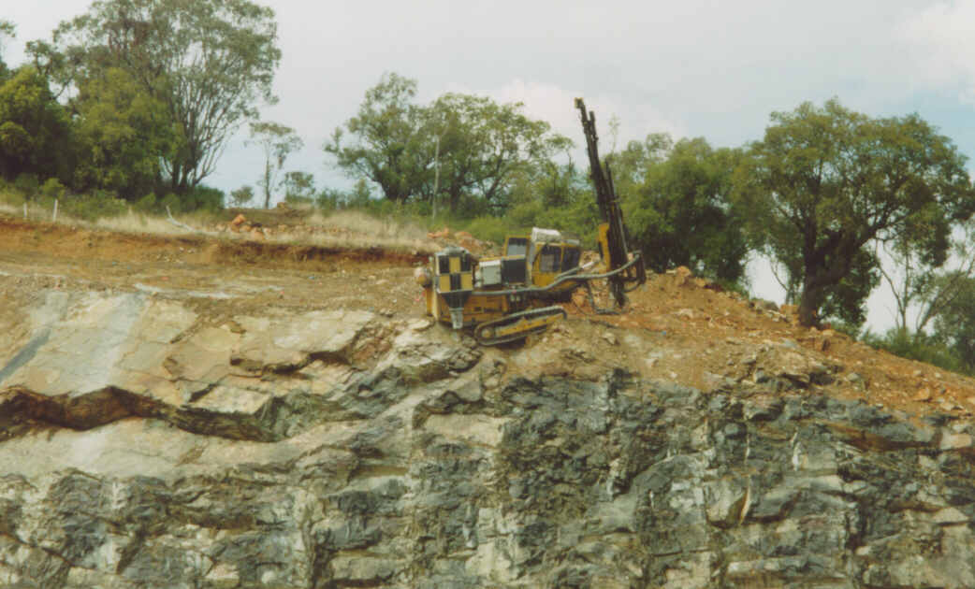

It is useful to consider these types of hazards when identifying work related hazards to ensure that a wide range is considered. The table below lists some types of hazards together with some examples.

At the end of the first step of the risk assessment you should have a list of hazard sources, the way in which that hazard occurs, the areas of the site or work process where it occurs, and the people exposed to that hazard. The hazard prompt list below will help in identifying hazards and developing inspection sheets.

|  |  |
| --- | --- |
| **Types of hazards** | **Examples** |
| Gravity | falling objects, falling from heights |
| Nip points | The point of contact between two objects such as a conveyor belt and rollers |
| Collision | Trucks hitting a light vehicle |
| Kinetic energy | projectiles, penetrating objects |
| Hazardous substances | dust and/or chemicals |
| Thermal energy | hot work such as welding and cutting |
| Extremes of temperature | effects of heat or cold |
| Radiation | sunburn, arc flashes from welding, exposure to laser beams |
| Noise | hearing loss from constant high noise levels or sudden extreme noise, such as an explosion |
| Electrical | Fire, electric shock, burnt skin |
| Vibration | White knuckle, whole body vibration |
| Biological | exposure to mould, dampness, bacteria in offices or amenities |
| Stress | production pressures, depression, anxiety |

Once a hazard has been identified it needs to be assessed for the related risk and then controlled.

## Risks

Risk is the possibility that harm (death, injury or illness) might occur when exposed to a hazard.

Risk assessment is understanding the nature of the harm that could be caused by the hazard, how serious the harm could be and the likelihood of it happening.[2]

By applying risk assessment to the hazards identified in the first step, you will rank the hazards on the potential injury or harm and the likelihood of these occurring. List these from the most to the least serious, e.g. from death by crushing to abrasion. The potential for fatal injury should be considered for each hazard type identified.

In assessing risks, consideration should be given to the likelihood of injury or disease, the duration of exposure to injury or disease sources and the likely severity of the outcomes.

|  |  |
| --- | --- |
| **Likelihood** | Frequency of injury – how often is the hazard likely to result in an injury or illness?  Duration of exposure – how long is the worker exposed to the hazard? |
| **Consequence** | Outcome – what are the consequences or potential severity of injury? |

Incomplete data or incomplete information regarding hazards of a work process may complicate the task. Risk assessment requires good judgment and awareness of the potential risks of a work process. Any person undertaking the risk assessment must have knowledge and experience of the work process and it may be required that a subject matter expert is also used to enhance the process.

Risk assessment should include:

* assessing the training or knowledge needed to work safely
* looking at the way jobs are performed
* looking at the way work is organised
* determining the size and layout of the workplace
* assessing the number and movement of all people at the site
* determining the type of operation to be performed
* reviewing the procedures for an emergency evacuation (e.g. accident, fire and rescue)
* looking at the storage and handling of all materials and substances
* work environment factors.

**An assessment of the risk will help determine the consequences (potential injury or illness) and assist the identification of methods to reduce the risk.**

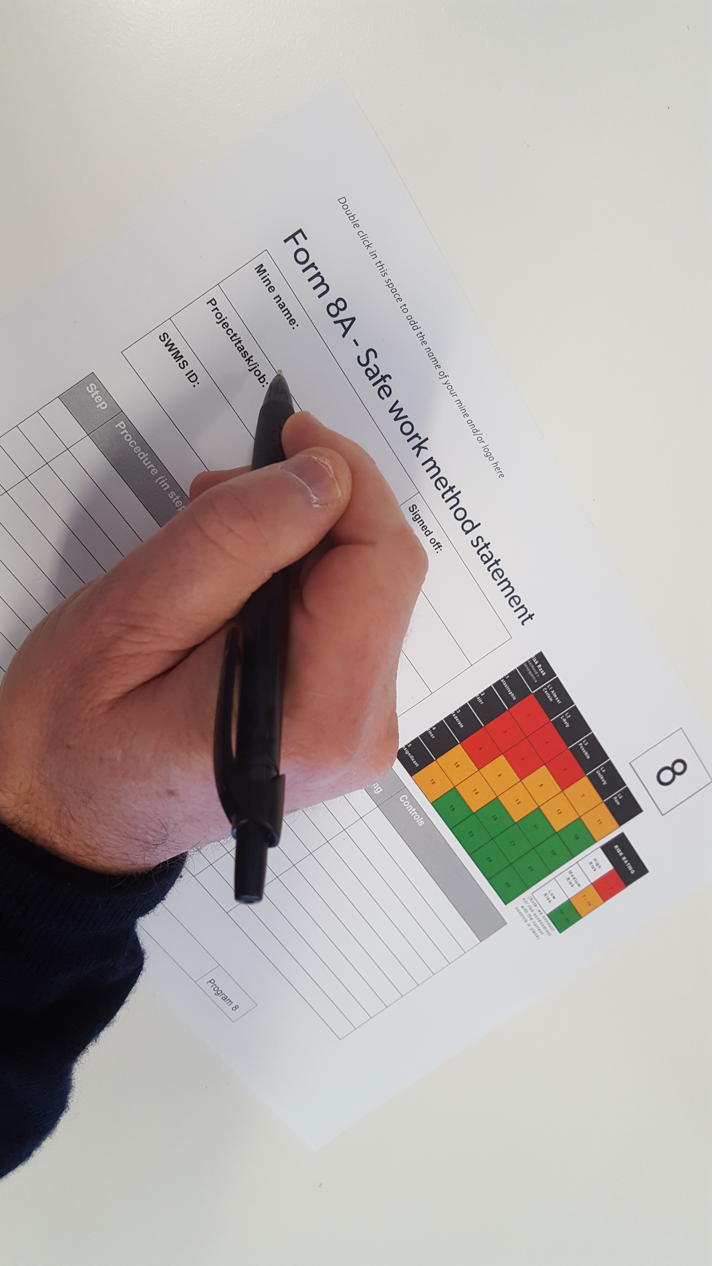

**Risk assessment rating example**

Risk = Likelihood (probability) x consequence

|  |  |
| --- | --- |
| **Likelihood** | **Consequences** |
| 1. Common or repeating occurrence | 1. Fatality |
| 1. Known to have occurred – “has happened” | 1. Permanent disability |
| 1. Could occur or “heard of it happening” | 1. Medical/hospital or lost time |
| 1. Not likely to occur | 1. First aid or no lost time |
| 1. Almost impossible | 1. No injury |

**Risk assessment matrix**

|  |  |  |  |  |  |  |  |  |
| --- | --- | --- | --- | --- | --- | --- | --- | --- |
| Risk Rank  Likelihood x Consequence | L1 Almost Certain | L2  Likely | L3  Possible | L4  Unlikely | L5  Rare |  |  |  |
| C1  Catastrophic | 1 | 2 | 4 | 7 | 11 |  | RISK RATING | |
| C2  Major | 3 | 5 | 8 | 12 | 16 |  | High Risk | 1 – 6 |
| C3  Moderate | 6 | 9 | 13 | 17 | 20 |  | Medium Risk | 7 – 15 |
| C4  Minor | 10 | 14 | 18 | 21 | 23 |  | Low Risk | 16 – 25 |
| C5  Insignificant | 15 | 19 | 22 | 24 | 25 | *(Note: we conduct our risk assessment with the current controls in place)* | | |

Using the risk assessment rating table and matrix you will have a risk rating for each of the hazards found. The higher the risk rating, the more likely people will be injured.

Example

*During a site inspection it was found that the walkway around the jaw crusher had no handrail or guards in place to stop people from falling into the crusher.*

*Using the risk assessment rating:*

* *The likelihood of injury was* ***A*** *- This was because it is the main walkway from one part of the site to the other, with people often exposed to a potential fall into the crusher.*
* *The consequence was* ***1*** *- If someone was to fall into the crusher when it was working they would more than likely be killed.*

*By transferring these ratings to the matrix:*

**Likelihood A * Consequence 1 = Risk Rating of 1 (or HIGH)**

Once you have identified the hazards and placed them in order of risk, you need to put in place controls to manage the risks of those hazards.

## Risk control

There is a hierarchy of controls or preferred order of control measures, which range from the most effective to the least effective. The hierarchy of control measures is:

**Elimination** - removing the hazard or hazardous work practice from the mine. This is the most effective control measure.

**Substitution** - replacing a hazard or hazardous work practice with a less hazardous one.

**Isolation** - stopping people from interacting with the hazard e.g. machine guarding, remote handling.

**Engineering control -** if the hazard cannot be removed, replaced or isolated, an engineering control is the next preferred measure. This may include changes to tools or equipment, providing guarding to machinery or equipment.

**Administrative control -** includes introducing work practices that reduce the risk. This could include limiting the amount of time a person is exposed to a particular hazard.

**Personal protective equipment (PPE) -** should be considered only when other control measures are not suitable or to increase protection.

There may be circumstances where more than one control measure should be used to reduce exposure to hazards.

By using the above controls you will be able to remove or reduce the exposure of the hazard to employees. When setting-up these controls it is always better to remove the risk instead of issuing employees with PPE.

## Regular monitoring

Constantly reviewing control measures is important to ensure they continue to be relevant and stop or control exposure to hazards or hazardous work practices.

Engineering controls should be regularly tested to ensure they work. Performance testing and evaluation standards should be set up.

1. Workplace inspections and hazard reporting

Workplace inspections are one of the best tools for finding problems and assessing their risks before accidents or other losses occur. They are also an invaluable method of ensuring that previously agreed controls remain in place and are effective. A well-managed inspection program can meet goals such as:

* 1. Identifying potential problems that were not anticipated during design or task analysis. Standards overlooked during design and hazards not found during job/task analysis become more apparent when inspecting the workplace and workers.
  2. Identifying equipment deficiencies. Among the basic causes of problems are normal wear and tear and abuse or misuse. Inspections help managers find out if equipment is getting worn to a substandard condition, an inadequate capacity or is being used improperly.
  3. Identifying improper employee actions. Since inspections cover both conditions and practices, they help people spot substandard methods and practices that may cause loss.
  4. Identifying effects of changes in processes or materials. Processes frequently change from the original design. As different materials become available, or as original materials are restricted, changes are made. The changes occur gradually and their total effects may go unnoticed. Inspections give managers, supervisors and others regular opportunities to concentrate on materials and problems to see what’s going on.
  5. Identifying inadequacies in remedial actions. Remedial actions are usually taken for specific problems. If they are not properly developed, they can cause other problems. If they are not properly implemented, the original problem recurs. Inspections give follow-up feedback on how well the remedial actions are working.
  6. Providing management self-appraisal information. The inspection is an excellent opportunity for appraising management and supervisor performance. It is a means for examining the way things are being managed, giving you a picture of:
* well-conditioned equipment or key items that are about to break down
* efficient layout or poor use of space
* tools in order or scattered where they must be searched out when needed
* materials ready for use or buried behind and under things where they have to be dug out
* safe work areas or ones with slip and trip hazards, unprotected points of operation, sharp points or edges, and health hazards
* clean work areas or ones that will required shut down and clean-up the next time an executive or a customer is scheduled to visit.

7. Demonstrate management commitment through visible activity for health and safety. Any management person worthy of the title, whether supervisor or executive, checks regularly to see that people have the things they need to get the job done. Commonly, the things are job knowledge, equipment and materials, as well as a healthy and safe workplace.

Inspection, detection and correction activities are hard to beat as ways of showing employees that their health and safety is important. When the manager makes regular safety tours and general inspections and when the supervisor does informal and formal inspections, people know that others care and that standards are important. They are prompted to play a part in the safety program and to take pride in the work they do, in their safety and their work.

Two broad categories are ‘informal’ inspections and ‘planned’ inspections. Both are important. Both are discussed below, with major emphasis on planned inspections.

## Informal inspections

This type comes so naturally that it needs very little explanation. It is simply the awareness of people as they go about their regular activities. Properly promoted and used, it can spot many potential problems as changes occur and work progresses.

Informal inspections have limitations. They are not systematic. They miss things that take extra effort to find.

Supervisors constantly have things on their minds. Preoccupied, they sometimes don’t realise what they are seeing. They may notice a few specific isolated hazards, but not the total picture. They may forget to follow up.

To overcome this problem, some supervisors carry a pocket notebook with memory ticklers. These are notes of problem items to check on and remedial actions to be taken. When items are corrected they are crossed out.

Some sites have formalised the informal inspection by installing a Take 5 or Take 2 risk assessment that is used before starting activities, (see section 7 for information).

## Planned inspections

As valuable as informal inspections are, they are not enough. They do not meet all needs for inspection. There are also critical needs for planned inspections – such as critical parts/items inspections, housekeeping evaluations and general inspections.

Regular inspections of all aspects of the workplace – plant (fixed and mobile), vehicles, buildings, yards and site – are necessary to pick-up and deal with hazards before they result in incidents occurring.

Workplace inspections are part of ongoing risk assessment and help in identifying which parts of your SMP are working well and those that aren’t working well. These are all part of continually improving your SMP and in turn the safety of those in your workplace.

What needs to be inspected, how often, what do you need to look for, who is doing the looking and what has to be done with the information collected will make up your inspection program.

Conducting the inspection. Here are some key points that will help make inspections more effective.

1. **Refer to a map and checklist.** Cover the area systematically. Be thorough. Follow the planned route so you give each area the appropriate attention and look at the appropriate items. Without checklists, people often become interested in the process and fail to see the problems.
2. **Record the positive.** Make brief notes of what you have looked at and found to be satisfactory.
3. **Look for off-the-floor and out-of-the-way items.** Without endangering yourself or others, make sure you get a complete picture of the whole area. Look in closed rooms and cabinets. Ask operators to start up machines not in use (but in workable condition). It’s often items outside normal operations that cause problems. Spend enough time looking for the things that might be missed in routine supervision and informal inspections.
4. **Take immediate temporary actions.** When any serious risk, hazard or danger is found, do something right away. See that the proper supervisor shuts down operations if the dangers are out of control. Put up barriers to isolate hazards. The action should be appropriate to the risk, but should always remove, lower the risk or correct the problem. If a manager or outside inspector is doing the inspection, the area supervisor should make sure the problem is properly understood, is valid and the response is prompt.
5. **Describe and locate each item clearly.** Write down a concise simple description of the problem. Give an exact location. Use established names and markings to pinpoint locations. Photograph to aid the written descriptions. Always write a full description on the spot. Don’t rely on memory or even on short notes. Also, remember that other people may need to locate the item in your absence.
6. **Prioritise the hazards.** It enables managers to give priority, in the budgeting of personnel and material resources, to the most important problems.
7. **Determine the basic causes of unsafe actions and conditions.** The same things will occur over and over again unless the basic causes of the problems are uncovered.

Answer the ‘why’ questions:

* Why does the unsafe condition exist?
* Why did the person perform in an unsafe manner?

Dig out the basic causes (personal factors and job factors) behind the symptoms (unsafe practices and conditions). Never accept a quick-fix without answering the question, does it address the basic causes?

C:\Users\stoopk\Pictures\spotlight.PNG

**Purpose**

* to identify hazards in all areas of the workplace through a series of planned inspections to enable them to be dealt with promptly
* to involve experts in the workplace in risk assessment
* to provide records of the identification and correction of hazards for comparison (continuous improvement) and trend spotting (recurring problems).

1. Health control plan

## Work environment

Mining/quarrying/extractive industries operations can include the exploration, disturbance, removal, washing, sifting, crushing, leaching, roasting, evaporation, smelting, refining, pelletising, rehabilitation and decommissioning of operations relating to any rock structure, stone, and fluid or mineral. Workers in this industry may be exposed to mineral dusts, diesel exhaust emissions, and a wide range of hazardous chemicals, either used during mineral processing/treatment or in the maintenance and repair of plant and equipment.

It is possible to measure physical, chemical and biological hazards. These activities are referred to as work environment monitoring. Examples are dust, heat, noise, vibration, radiation, fumes and bacteria.

Much research has been done to determine what are considered to be safe levels of exposure to these hazards and this data has been set down in standards, codes of practice and legislation. Requirements for initial testing and ongoing monitoring of the levels of these hazards present in the workplace has also been determined and are set down in these documents along with guidelines, guidance notes and codes of practice. Some of the preliminary testing may be done by those in the workplace but much of the testing requires specialist equipment and expertise.

## Dust

All dust that can be breathed in must be considered harmful in some degree. Even where there may be only slight danger to the lungs, there is very likely some adverse effect on the lungs, particularly to asthmatics or sufferers of hay fever.

Dust particles of size ranging from 0.001 to 0.1 mm (1 to 100 microns) are a threat to health when they become airborne. They reduce visibility, create an uncomfortable environment (irritation of eyes, ears, nose, throat and skin) and possibly result in damage to the tissues of the lungs. Included in these potentially harmful dusts are silica, asbestos, carborundum, diatomite, and talc – each of which can produce its own form of lung damage when dust control is inadequate.

The most common harmful dust contains silica; it would appear that the harmfulness increases with the increase in the percentage of silica in the dust. Also, the dust that is considered most harmful is that which is less than 5 microns in size. That is, particles smaller than 0.005mm. As this dust is not visible, it is often not considered harmful and mine operators and workers do not take the necessary measures to identify, assess and control dust exposure.

## Noise

Sound is what we hear. Noise is unwanted sound. The difference between sound and noise depends on the listener and the circumstances. Noise can be hazardous to a person’s hearing if the sound is loud and if he or she is exposed long and often enough.

Measuring noise levels and workers’ noise exposures is the most important part of a workplace hearing conservation and noise control program. It helps identify work locations where there are noise problems, employees who may be affected and where additional noise measurements need to be made.

Noise surveys are conducted in areas where noise exposure is likely to be hazardous. A noise survey involves measuring noise levels at selected locations throughout an entire plant or in workplaces underground to identify noisy areas. This is usually done with a sound level meter.

## Vibration

Operators and passengers of earth-moving equipment such as haul trucks, dozers, loaders and tractors are exposed to whole body vibration. Lower back pain is the most common injury. Other injuries include neck and shoulder problems, herniated discs and early degeneration of the spine.

Workers operating hand-held machinery may suffer, particularly in cold climates, from the vibration syndrome. This is typified by aches in arms and shoulders, loss of nerve conduction and vibration white finger. This condition, also known as dead finger, can lead to gangrene in hands and fingers. Similarly, workers using pneumatic chipping hammers, rivet machines, pneumatic rock drills and chainsaws, may experience vibration white finger and vibration syndrome.

The rapid motion of an object such as a pneumatic drill, chainsaw, tractor seat, or the seat of mining or earth-moving equipment causes vibration.

Vibration can cause injuries including:

* bone damage, rubbing of bones and joints causing inflammation, especially along the spine
* digestive problems
* changes to cardiovascular, respiratory, neurological, edocrine and metabolic systems
* impairment of vision, balance or both
* reproductive organ damage in both men and women.

## Ergonomics

Manual handling is not just about lifting heavy objects. It includes any activity requiring the use of force exerted by a person to lower, push, pull, hold or restrain a person, animal or thing.

Placing boxes and other items on shelves, painting, gardening, cleaning, writing and typing are some examples of manual handling tasks.

Manual handling injuries include:

* strains and sprains
* neck and back injury
* slips, falls and crush incidents
* cuts, bruises and broken bones
* hernia, strained heart muscles
* occupational overuse syndrome (OOS), once known as repetitive strain injury (RSI).

The employee should be informed and trained in:

* safe manual handling methods
* specific manual handling hazards
* safe work procedures
* using manual handling aids
* the right to ask for help.

Most manual handling injuries can be prevented by education, training, and supervision. Safe work procedures should be prepared by employers with the help of employees to care for the special needs of young and new workers.

## Radiation

Ultraviolet radiation (UV) from the sun or welding arcs is the most common source of radiation in above ground mines and quarries.

Although exposure to small amounts of UV radiation can have beneficial effects, such as vitamin D synthesis in the skin, overexposure can cause serious acute (short-term) and chronic (long-term) health effects.

Consideration may be given to different outdoor work programs, and to the opportunity to undertake alternative tasks when the sun is most intense. Canopies and shade covers are also essential in limiting operator exposure.

The use of personal protection is also important in reducing the effects of solar UV radiation.

It is also important to ensure that the use of personal protection itself does not create a secondary hazard to the worker. For example, loose clothing worn near outdoor machinery, such as a post-hole digger/auger, may cause a secondary hazard. Heat stress may also be a secondary hazard when wearing some types of protective clothing and performing heavy manual labour.

## Health surveillance

It is not always possible to eliminate a hazard. Where hazards and their risks are controlled only, one way of measuring the success of the control strategies is to monitor the effect on people and their health. An example in mining/quarrying would be dust and lung function testing.

Monitoring people’s health following exposure to the hazards should never be seen as a control in itself but only as an indicator of the effectiveness of the controls you have put into place.

Another form of health surveillance involves monitoring people’s health to ensure that they remain fit to perform their tasks when their health may directly impact on the health and safety of others. An example would be the health of the drivers of heavy goods and dangerous goods vehicles.

Health surveillance may also give people early warning of medical conditions that can be treated before they become a problem, affect their health or prevent them from working.

Inhalation of mineral dusts such as silica or asbestos, remains a concern in the industry. Therefore, a health surveillance program is aimed at monitoring respiratory symptoms. Audiometric testing is also done when mine/quarry/extractive industries workers are exposed to very high noise levels and may be at risk of noise induced hearing loss.

## Fitness for work

Fit for work means an individual is able to perform work competently and in a manner which does not compromise or threaten the safety or health of themselves or others.

An individual’s fitness for work may be affected for a variety of reasons including the adverse effects of medical conditions, fatigue, stress, alcohol or other drugs, and an individual’s emotional state.

These factors may lead to work performance and behavioural issues which can result in a higher likelihood of workplace incidents.

### Alcohol and other drug use

Employers must ensure the health and welfare of all employees at work. Employers must also ensure that people other than employees, who are on the worksite, are not exposed to risks to their health and safety.

Alcohol and other drug use can occur at any workplace.

The abuse of alcohol and other drugs may damage physical and mental health. The impairment of behaviour can cause affected employees to injure themselves or others. Workmates are often placed in the uncomfortable position of feeling obligated to cover for poor work performance, or ‘to dob’ in a mate for their own good. Employers may be faced with lateness, inefficiency and absenteeism, lost time and production from dangerous incidents and damage to plant, equipment and other property.

### Policy

Dealing with alcohol and other drug-related hazards requires a policy. It should apply to all employees and be developed by management in consultation with workers. Procedures should be set up to give support to this policy, to identify and deal with cases of alcoholic or drug-addicted employees, and to ensure that these are followed.

The aim of any workplace policy and procedures should be prevention, education, counselling and rehabilitation and it should be a part of the sites overall occupational health and safety strategy.

The policy should be well publicised within the workplace and have a suitable training and education program for all staff.

The policy should be included in induction and training. Place the policy on noticeboards for all people who work at the site to refer to.

The policy could have a statement from the site including:

* it’s commitment to providing a safe and healthy workplace
* the consultation process
* the aims and expected outcomes for the policy
* detailed procedures.

### Procedures

When developing procedures, management should recognise that alcohol and other drug dependency is an illness that can be controlled and treated.

Workers who have this problem may be given the same opportunities to obtain help as a sick or injured worker.

If any person needs to take prescription medicine for an illness, and this may affect their performance at work, they should report it to their supervisor so that they can be given the right task.

*Example*

*The following procedure is an approach to continued alcohol and other drug abuse at the site:*

* *lost time should be deducted from their annual sick leave*
* *the employee should be required to be interviewed by the manager to determine the extent of the problem*
* *if appropriate, the employee should attend an appointment with a professional organisation for further help*
* *at all times the confidentiality of the employee must be maintained.*

Where there is an ongoing disregard for the site’s alcohol and other drug policy, disciplinary action may be taken.

### Alcohol and drug policy awareness training

Part of the mine operator’s role is to train people in the application of the alcohol and other drug policy and procedures. Supervisors must have training to be able to identify workers in need of treatment.

Training should cover:

* what constitutes harmful drug and alcohol use
* dealing with the long-term user and with people who become intoxicated in one-off situations
* the effects of alcohol and drug use on health, safety and work performance
* general statistics on workplace drug and alcohol use and related injuries and incidents
* the consequences for workers who fail to follow alcohol and other drug policy and procedures
* personal stress reduction methods
* ways of dealing with harmful alcohol and drug use
* who to approach in the workplace for assistance with an alcohol or drug problem
* skills for managers, supervisors, health and safety representatives and WHS committee members in identifying alcohol and drug use and how to manage the issue in their workplace
* the legal position (rights and penalties) of staff and management in relation to alcohol and drug use and drug testing
* the counselling, treatment and rehabilitation services available in the workplace and externally. Place contacts with phone numbers on noticeboards.

### Approaching a worker suspected of being under the influence

The approach taken when dealing with a worker whose work performance appears to be affected by alcohol or other drugs depends on the:

* workplace culture and structure
* rapport between the authorised person and worker
* communication skills of the authorised person
* position of the worker
* personality of the worker
* whether it is a case of long-term harmful use, or a one-off situation.

Options for approaching the worker include:

* by their supervisor or more senior manager
* by a person designated in the workplace policy
* by a fellow worker or peer.

The policy should state who is responsible for making approaches if initial contact produces a negative or hostile response.

1. Safe work method statements

Health and safety management systems are most effective when there is a system set up for identifying hazards in a structured process, assessing the risk of these hazards and devising measures to control the risk.

One of the most important control measures is the preparation of work method statements, work instructions and technical procedures, (often called a variety of names, with the most popular being safe work procedures, SWP or safe work method statements SWMS). These go towards ensuring that the necessary planning is done and facilitate the provision of written instructions on how to perform tasks in those processes where a lack of control could result in safety problems.

Depending on the maturity of your safety management system, a recognised method of identifying hazards has seen many businesses adopt a three-tiered approach to conducting workplace inspections before starting work:

1. **Routine task in a normal work environment**

Work that is considered low risk and is being performed as a routine task in a work environment that has not changed, can proceed with care and with no additional risk assessments.

1. **Non-routine task in same work environment or routine task in a changed work environment (informal risk assessment)**

Regardless of whether a SWMS is available and a non-routine task is being performed or the work environment has changed then an informal risk assessment is completed prior to commencing the task (often known as a Take 5, SLAM, STOP or Take 2).

If the informal risk assessment indicates that the residual risk (risk after controls are implemented) remains medium or high, then a SWMS is to be completed or reviewed.

1. **Non-routine task in a changed work environment (also includes new tasks)**

A structured risk assessment that involves the use of a pre-determined format, including consultation with workers, use of hierarchy of controls and assigned accountabilities is required. These are often referred to as JSAs (job safety analysis), however this publication uses the term safe work method statements (SWMS).

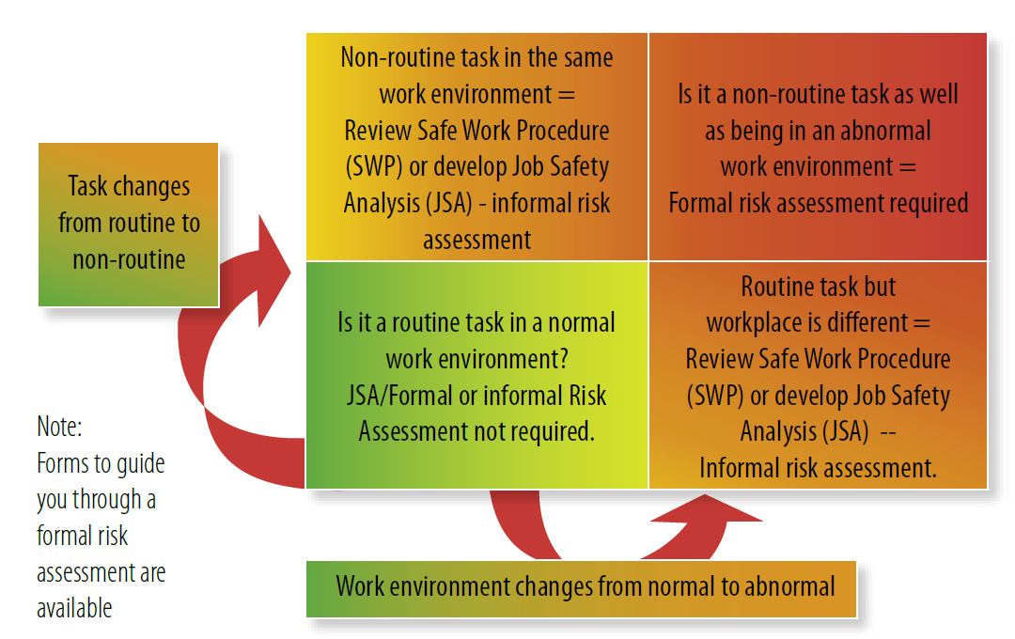

Safe work method statements should be developed for operating all equipment and machinery, and tasks that have safety implications.

Mining/quarrying/extractive industry operations should identify potential hazards and assess the risks arising out of work processes. Documented procedures and work instructions are then developed where necessary to manage work processes, machinery and equipment, and materials in a safe manner. Workers who perform the tasks should be involved in the development of those procedures.

The documented procedure should contain clearly written and easy to understand instructions. Workers will not always follow written procedures because of incorrect or poorly written procedures. SWMSs need to be accurate and sufficiently detailed.

A suggested method of developing a SWMS for a task is to carry out a step-by-step analysis of the task. SWMS is a course of action designed to review job methods (or steps), identify hazards, assess the risk of those hazards and develop safe work practices (also referred to as a job safety analysis, JSA, or job hazard analysis, JHA).

The SWMS technique is an effective way of encouraging and allowing employees to take part in safety assessment and accident prevention. Through SWMSs, they can make an important contribution towards the setting up and maintenance of safety procedures and practices. It can also be regarded as part of the consultative process, which is required under occupational health and safety and mine/quarry legislation (refer to Program 4 Consultation).

## Description

In this context, a job is a number of steps performed in a sequence to complete a work task. For example, repairing a head-pulley on a conveyor, operating a dozer on a highwall bench, assembling equipment or dealing with a breakdown.

The SWMS is the breaking down of a job into steps and writing down any potential hazards that you can identify in each step. This is done so that ways of controlling those hazards can be found and the control measures implemented.

There are five basic steps to completing a safe work method statement:

1. **Choose the job**

In choosing which jobs should be looked at, it is useful to begin with those jobs that have a high accident rate or where high risk is present. Remember that new jobs will have no accident or hazard history and the potential for injury or work-related illness may not be recognised unless a SWMS is performed before the new job is begun.

1. **Work out the job steps**

In working out the job steps it is useful to work through the job listing each step and making notes of what is done. Use the SWMS form (Part 2: Form 8A) to do this. You may have an existing form or design one that relates to how you do SWMSs.

1. **Observe the job**

The steps of the job can then be looked at separately to identify any potential or existing hazards for each step and the key factors related to safety. Write down any hazards or hazardous processes observed.

1. **Assess the risk for each identified hazard**

(refer to Program 5 Risk management).

1. **Find risk controls**

For each risk rating for the identified hazard, the relevant safety information and method of controlling the risk must be identified and then included in the new written safe work procedure to remove or control the hazard. You should try to remove the risk (redesign the way the job is done) as the preferred control.

C:\Users\stoopk\Pictures\spotlight.PNG

**Purpose**

A completed SWMS can be used for specific job instruction and is ideal for training since it shows an employee how to do the job in the best (and safest) way. It also standardises the job procedure so that everyone learns to do the job in the same safe way.

The SWMS can help the manager/supervisor to learn about the job to be supervised, even if they have not actually done the job.

The completed SWMS is a record showing that the mine has conducted hazard identification, risk assessment and risk control as is commonly required by health and safety legislation.

The SWMS should be used as a checklist when doing safety inspections or audits, as it tells the person conducting the inspection or audit what should be happening on any job. The SWMS provides a yardstick during any incident investigation, as it forms a reference to methods and practices.

Employees will take more interest in a task if they are asked to help in its analysis. Useful suggestions for increasing the safety factors and job restructuring may be offered, for example:

* some part of the work environment may need to be changed (materials, lighting, work area layout, ventilation, protective equipment)
* the number of times the job is done may be reduced
* complete change of a job method may be identified.
  1. Safe work method statement records

A copy of the completed SWMS should be kept on the job so it is handy for reference. The original SWMS document should be filed at a central location. Because a SWMS produces permanent instructions, it should be a continuing activity. The SWMS has to be kept up-to-date or the benefits will be lost over time. Incorrect information or an out-of-date SWMS can be dangerous.

In reality, changes are not needed very often but when they do occur, everyone concerned with the job should be told of the changes and instructed in the new procedures. The SWMS for a particular task should be repeated if:

* an accident occurs on a job covered by a SWMS
* a job step is changed
* a job process is changed
* a safety inspection shows that the job is not being performed according the SWMS.

### Safe work method statement pitfalls

There are three main pitfalls in developing SWMSs that could prevent them being as effective as they might otherwise be. These are:

* not listing all the hazards
* listing the hazards but taking no action
* making vague action recommendations.

1. Emergency plan

While the main purpose of your SMS is to prevent accidents happening through the identification, assessment and control of the risk of those hazards, it needs to be recognised that unplanned incidents (emergency events) can occur.

Each site needs to plan for these incidents. This section focuses on incidents that may be classified as emergency situations. These are incidents that could be assessed as unlikely to occur but with potential high consequences. A set of plans (known as the emergency plan) and procedures for how to deal with these events must be developed and regularly tested to ensure that the effects of these unplanned events are minimised.

The emergency plan for most small operations will be the same but the size and detail should fit with your particular site.

Emergency plans may include, but not be limited to, the following:

* Warning and alarm systems – installation, availability and testing requirements
* Emergency procedures – who does what when an emergency occurs (including evacuation)?
* List of key emergency personnel
* Emergency rescue equipment available on site
* Details of emergency services available
* Information requirements of emergency services
* Internal and external communication plans
* Training plans
* Drills and simulation exercises.

C:\Users\stoopk\Pictures\spotlight.PNG

**Purpose**

The purpose of the emergency plan is to:

* minimise the level of risk to life, property and the environment as a result of an emergency situation,
* identify the resources – people, equipment, information and knowledge – necessary to ensure that when used effectively, minimise that risk, and
* provide guidance for all employees – what to do in emergency situations.

## Planning for emergencies

All potential emergency situations need to be identified and emergency procedures documented for preventing and lessening injury and illness.

## Risk assessment

Identifying potential emergency situations is the key to having effective emergency plans. Developing the plan begins with a risk assessment. The results of the risk assessment will show:

* how likely an event is to happen
* what means are available to stop or prevent the event
* what is necessary for the given event.

You may use the high-risk areas identified from completing hazard identification and risk assessment (refer Program 5: Risk management).

The risk assessment may result in a list that could include:

* fire
* explosion
* flood
* significant collapse of workings of the mine
* major trauma (injuries)
* medical emergency (general and specific such as heart attack)
* hazardous material or chemical spill
* mobile plant or vehicle collision
* illegal acts such as bomb threat or un authorised entry

Any of the above can be related. For example, if a dump truck goes over a highwall there may be explosion, fire, collapse of the highwall, injury and hazardous material spill.

## Identifying emergency events

At the planning stage, it is important to include workers who may have had experience in emergency work, such as volunteer fire fighters, volunteer rescue service or first aiders. They can help identify emergencies and the response procedures needed. Other emergency events may be known from previous experience or local knowledge, such as bushfire or flooding. Also look at other risk assessments that you have done such as safe work procedures, workplace inspections and accident investigations.

All these various sources of information can help you determine what will be an emergency event. An emergency event will have major impacts at the mine and will require actions because of these impacts.

*Example*

*Prolonged heavy rainfall may cause flooding of the local river that runs near the mine/quarry/extractive industry site. A 1 in 100-year flood may occur causing the site to be cut-off from road access and communications. Response may include flood level monitoring, early warning and protection measures (such as sandbagging) and evacuation if continued flooding becomes a threat to life.*

Table 1 lists some possible major impacts and required actions based on these events.

|  |  |
| --- | --- |
| **Possible major impacts** | **Required actions** |
| * sequential events (for example fire after explosion) * evacuation * casualties * damage to equipment and machinery * loss of records/documents * disruption to work | * declare emergency * sound the alert * evacuate persons from the danger area * close down main power supply * call for external help (such as ambulance) * start-up rescue operations * attend to casualties * fight fire |

## Emergency resources

The final consideration is a list and the location of what emergency equipment may be needed. Table 2 lists some possible emergency equipment and locations.

|  |  |
| --- | --- |
| **Emergency equipment** | **Location** |
| * medical supplies (first aid kits) | * main office * weighbridge / workshop * mobile plant |
| * firefighting equipment: * extinguishers * fire hose reel * bush fire kit | * office and plant, mobile plant * workshop and main office * workshop store and main gate |
| * ambulance | * offsite ambulance service |
| * emergency chemical spill kit | * No 1 feed bin |
| * trained personnel | * all workers senior first-aid trained * two persons trained in heights rescue and confined space rescue |

## Preparing an emergency procedure

The emergency plan will be made up of procedures for the identified emergencies. Emergency response is about making rapid decisions due to time and the circumstances. Normal communication and decision making may not work.

The emergency plan should have specific duties, responsibilities and authorities.

Some of these are:

* who reports the emergency?
* who starts the emergency response plan?
* who has overall control?
* who establishes communication?
* who alerts emergency personnel?
* who orders evacuation?
* who alerts external emergency services?
* who provides first aid?
* who advises relatives of casualties?
* who sounds the all-clear?

To ensure good emergency response, you should:

* develop an evacuation procedure
* develop procedures for emergency response for your specific major emergency events (e.g. flood, fire, explosion, medical, tyre fire)
* install and maintain all necessary firefighting and emergency equipment
* train all emergency personnel as required
* appoint first aid officers
* provide a site plan of the operation, including exits, safe evacuation paths, location of fire fighting and emergency equipment, emergency phones and evacuation assembly areas
* identify the local emergency services (fire, ambulance, police, SES, VRA) and how to contact them.

## Emergency training

Employees need to be trained to deal with emergency events. All workers should be trained and educated so they know what to do for their role and responsibilities in the event of an emergency.

There should be a schedule developed for training and refresher training for all workers for all emergency events identified. Emergency drills should be conducted at least every 12 months to make people aware of their immediate actions, how to raise the alarm, the position of firefighting equipment and the location of emergency assembly areas.

The emergency response plan should be reviewed (and where necessary revised) after an incident or emergency event.

1. Mechanical engineering control plan

Under section 30 of the WHSMPS Regulation the mine operator must prepare and implement a principal control plan for the risks associated with the mechanical aspects of plant and structures at the mine.

At a surface mine, the MECP must be developed and periodically reviewed by a person who is, or who is under the supervision of a competent person.

The mechanical engineering control must set out the control measures used to prevent injury from the following both when operating plant and when working on it (for example when undertaking maintenance):

* explosions
* the unintended operation of plant
* the unintended release of mechanical energy
* the catastrophic failure of plant or structures
* fires being initiated or fuelled by plant
* exposure to toxic or harmful substances.

In summary, key considerations for a mechanical engineering control plan for a surface metalliferous or extractives operation include:

* the standards of engineering practice to be followed throughout the lifecycle of the mechanical plant and installations
* the safe operation of conveyors, winding systems, mobile plant and dredges
* the safety of plant and installations
* fitting appropriate fire suppression and shut-down systems
* fitting appropriate heat detection and automatic trip sensors
* rollover and falling object protection
* seatbelts and other restraints
* protective canopies
* safe storage and use of pressurised fluids (including gases)
* means for the prevention, detection and suppression of fires on mobile plant and conveyors.

See the *Mechanical engineering control plan code of practice* for full details of how to develop and implement an effective mechanical engineering control plan.

Poorly maintained, untidy, run down and unpainted machinery indicates a lack of care and responsibility. This can lead to unsafe conditions and procedures. Any breakdown of equipment and machinery can be costly and affect your business. Unplanned maintenance is usually ad-hoc and done in poor conditions. A program of planned maintenance can avoid these conditions and improve health and safety at the mine/quarry/extractive industry site.

## Advantages of planned maintenance

* Routine checks by operators can prevent breakdowns and early wear which are costly and may place people at risk.
* Maintenance personnel are able to reduce or eliminate risks to themselves by planning lockout procedures, access, materials handling and other procedures in advance.
* Repairs are more likely to be permanent rather than temporary patch-ups, which may not be reliable and often end up as the permanent solution until the next breakdown.
* Production personnel are less likely to be exposed to risks when machinery malfunctions demands manual intervention.
* Down time is planned and results in less disruption of personnel and production.
* Maintenance costs are controlled and which allows for the best use of resources.

## Health and safety requirements

Health and safety legislation commonly places a general duty on mines/quarries to maintain machinery and equipment in a safe operating condition.

Controls, emergency stops, access and guarding systems must be maintained in full functional order. Priority for this should be no less than for maintaining any other part of a machine. Machines that are designed to function automatically should be maintained in this condition to avoid the need for operators to intervene manually and place themselves at risk.

Equipment that is solely or mainly for the health and safety of workers must have a high priority for maintenance. These include:

* all personal protective equipment
* air filters and air conditioners in dusty or hot work environments
* seats, seat-belts and controls on mobile machines
* windows
* dust seals etc.

## Routine maintenance tasks checklists

Checklists should be prepared and used for routine tasks (see below). These should include all tasks and be based on machinery and equipment manufacturer recommendations and your own experience. Using these checklists will provide information for operators, supervisors and managers.

Daily checks should include:

* oil levels for lubrication and hydraulics
* coolant levels
* fuel levels
* filters checked for cleanliness
* operation of instruments
* functioning of controls
* effectiveness of brakes and other safety critical devices
* electrical connections and switches
* condition of tooling
* reporting leaks, wear, damage, presence and effectiveness of guarding.

Safe work procedures must be observed while carrying out the above maintenance tasks.

Suggested aids in planning maintenance:

* manufacturers' handbooks and maintenance schedules
* records of maintenance work performed on major plant items
* site plant register
* external diagnostic services e.g. SOS (scheduled oil sampling)
* site maintenance schedules/checklists
* computer-based schedules which include reminders and completion of audit reports

1. Electrical engineering control plan

Under section 30 of the WHSMPS Regulation the mine operator must prepare and implement a principal control plan for the risks associated with electricity at the mine.

At a surface mine the EECP must be developed and periodically reviewed by a person who is, or who is under the supervision of an electrical engineer or if no engineer is required a competent person. The principal control plan must be documented, and so far, as is reasonably practicable, be set out and expressed in a way that can be readily understood by the people who will use it.

The electrical engineering control plan must set out the control measures used to prevent injury from the following for risks to health and safety associated with electricity at the mine:

* injury caused by direct or indirect contact with electricity
* injury caused by working on electrical plant or electrical installations
* the unintended initiation of gas or dust explosions
* the unintended operation of plant
* the occurrence of uncontrolled fires.
* In summary, key considerations for an electrical engineering control plan for a surface metalliferous or extractives operation include prevention of harm from electricity sources
* prevention of fires being started by electricity
* prevention of unintentional starting of electrical plant
* fitting electrical safeguards
* competencies required for workers carrying out electrical work
* the reliability of plant and installations used in monitoring hazard controls and communication systems
* a maintenance management system
* safe work practices for working on high voltage installations
* any other requirements of the WHS or WHSMPS Regulations in relation to the safety management of electrical plant and installations and electrical engineering practices.

To achieve an acceptable level of risk and create a safe workplace the following matters should be considered in the development of your EECP and other systems:

* Competent (licensed) people to perform electrical tasks and to be involved in the development and implementation of electrical control documents.
* Safe work practices and procedures
* Fit for purpose equipment and installations
* Adequate maintenance practices to keep installations in a fit for purpose condition
* Use sound engineering practices when designing plant
* All recognised potential hazards are made safe until technical assistance is obtained
* To identify, record and close out defects that are detected
* Allow adequate time and resources to complete required work
* Appropriately supervised and engaged via a sound contractor management system

1. Accident and incident reporting

## Introduction

A key part of a SMS is to identify hazards and to evaluate accidents and near-miss incidents, so that the chances of the same or similar incidents happening again can be removed or at least reduced. To achieve this requires good investigation and keeping of records to monitor progress.

## An accident or an incident?

For the purpose of preventing accidents, an incident is an unplanned event that causes injury or illness, or damage to machinery and equipment, or the possibility of injury or damage. An event that does not cause injury or damage is called a *near miss* or *near hit*.

## Reporting

Why do we need to know about workplace injuries, illnesses and damage?

* 1. It is a legal requirement for people to report them and for the site to record them.
  2. When people are injured or become ill it is important that they receive the right treatment.
  3. The information that needs to be recorded can be valuable in determining the how, when, why and where of accidents that can be used to stop further accidents from happening.

Certain information must be recorded to meet your health and safety legal requirements. Health and safety legislation requires that some types of accidents and incidents must be reported to the relative statutory authority and fully investigated. In most states of Australia all accidents, incidents and near misses that happen at mines and are described in legislation must be reported to the relevant statutory authority within specified timeframes. There are generally accident/incident report forms available from those authorities for doing this. Specific guidance and information for reporting incidents and injuries at NSW mines is available on the NSW Resources Regulator website.

Workers’ compensation legislation generally requires PCBU to keep a register of injuries, and in some cases to report injuries to the relevant authority. You must be aware of the legislation that applies to your operation and what your reporting requirements are.

Everyone in the workplace must be able to report and/or record their injuries or illnesses. These information records must be kept for a defined period of time.

## Accident and incident investigation

Accident investigation is a process of gathering facts and breaking them down by continually asking why. Only then can you identify the underlying causes, put controls in place and prevent it happening again.

Because accidents are never caused by a single factor, it is important to identify all the causes and put in the right controls.

*Example*

*The reason the operator’s arm became trapped was the conveyor was not guarded properly and there was no procedure for safely doing this job. This highlights the need for:*

* *adequate guarding on all conveyors*
* *development of safe work procedures*
* *training all operators in hazard identification.*

You can decide which other types of accidents or incidents need investigation either individually or when trends start to show up.

### What should be investigated?

All accidents and incidents should be investigated to the degree suggested by the level of risk. This investigation should take place as soon as possible after the incident happens. Getting the investigation started quickly is important as crucial evidence can be disturbed or destroyed as time passes. Important information from people involved in or witnessing the accident or incident may be lost if the investigation is not started as soon as possible.

Investigations should not be confined to the immediate scene. Information from safety records, safe work procedures, manufactures handbooks and authoritative (e.g. government) publications may indicate particular areas of concern.

### Who investigates?

The manager and/or supervisor responsible for the area where the incident occurred should investigate each accident or incident. Involving a worker or worker representative who knows the work area in the investigation will help to identify the causes and corrective actions required.

Incidents that are reported to statutory authorities may require the involvement of the mine manager and experts from outside the site. Anyone who carries out an investigation should have some training.

It is advisable that more than one person carries out accident and incident investigation.

## Where to from here?

The investigation should have concluded the following:

* identified the cause(s) of the accident or incident
* identified and implemented the necessary corrective action
* implemented or modified controls necessary to avoid a repeat of the accident or incident
* recorded the changes in safe work procedures from the corrective actions
* determined who is responsible for completing the corrective actions.

C:\Users\stoopk\Pictures\spotlight.PNG

**Purpose**

* Accident and incident investigations are aimed at preventing future accidents and incidents, it is not about blame. This should be stressed to employees who are interviewed in an investigation, so that all relevant information can be gained.

1. Contractor health and safety management

Contractors and sub-contractors play a major role at many small mines/quarries/extractive industry operations. Contractors carry out work that employees of the site are unable to do such as electrical installations, complex mechanical repairs, change out of large earthmoving rubber tyres and specialist welding of alloys. Contractors may undertake tasks that your employees do not have the skills or equipment to do such as drilling and blasting.

Your duty of care extends to the health and safety of all people who undertake tasks at the mine – full-time, part-time and casual employees, contractors and their employees, sub-contractors and consultants. They, in turn have certain responsibilities to you as the employer (principal) and it is in pulling these two sets of responsibilities together that a program for contractor management can be developed.

Managing contractors’ health and safety does not necessarily mean telling them how to do their job. It’s about establishing the health and safety standards for the mine, as set down in your mine safety management system, which everyone has to meet. If the contractor is able to meet your standards through their own safety management plan, then all you need to do is to monitor them. If however, the contractor does not have their own safety management plan then it would seem reasonable to expect that they will comply with the one you have. Once you have made a decision with respect to which safety management plan/system the contractor is going to work under, written confirmation is required to confirm that the plan has been reviewed and is consistent with the other entities system/plan.

The level of risk that is involved in work to be done can assist in determining the level of control that needs to be used over the contractors.

C:\Users\stoopk\Pictures\spotlight.PNG

**Purpose**

* to ensure fulfilment of duty of care obligations for the health and safety of contractors and their employees
* to provide a systematic risk assessment based approach to the management of contractor health and safety
* to structure contracts which have the power to impose health and safety standards
* to provide evidence of due diligence through documentation of the contractor health and safety management process.

For high risk contracts, that is contractors who undertake tasks that have risks that have been assessed as high such as drill and blast activities, the contractor should prepare a health and safety management plan. All large contractors should have their own health & safety management plan that they can easily customise to suit your operations.

This health and safety management plan could contain, but not be limited to:

* health and safety policy statement
* organisational chart showing key personnel
* responsibilities, authority and training of people with safety functions
* list of personnel with evidence of required skills and competencies
* employee and sub-contractor selection, placement and training methods/programs
* health and safety training previously attended by personnel prior to job start (including specific induction)
* accident investigation (procedure, documentation)
* injury/illness reporting (procedure, documentation)
* workplace inspections and auditing (procedure and documentation)
* hazard reporting (procedure, documentation)
* employee communication/consultation/participation e.g. tool box talks, health and safety committee
* scope of works
* safe work procedures/job hazard analysis process (to be developed/modified as project proceeds)
* static plant (certification reports)
* mobile plant safety certification (re inspection prior to coming on site and maintenance protocol)
* hazardous substances control (listing and MSDS register)
* personal protective equipment and clothing (policy and register)
* health and safety and environment controls (eg noise, vibration)
* rehabilitation (process and documentation)
* emergency response and evacuation (procedures, documentation)
* disciplinary action (policy and procedures)

## Labour hire

WHS legislation commonly requires every PCBU to ensure so far, as is reasonably practicable, that workers at work are safe from injury and risks to health. Labour hire agencies must do all things reasonably practicable to ensure their contract workers are not put at risk of injury or illness when working for a client.

The employment relationship between agencies and their contract workers is different from a normal PCBU/worker relationship. The difference is that agencies do not employ people to carry out work for them but for a client. The agency does not supervise the tasks the contract worker will be doing or control the workplace where they do the work. Therefore, some agencies may believe that PCBU obligations do not apply to them or cannot be practically carried out.

Nevertheless, this does not diminish the responsibilities of agents to do all things reasonably practicable to ensure their contract employees are not put at risk of injury or illness when working for a client.

Clients of the agency become the host PCBU once they employ contract labour. While it is the legal responsibility of the agency to ensure the health and safety of their contract workers, the host PCBU has an equal responsibility to contract workers working for them.

**Contractor hauling overburden at a slate mine.**

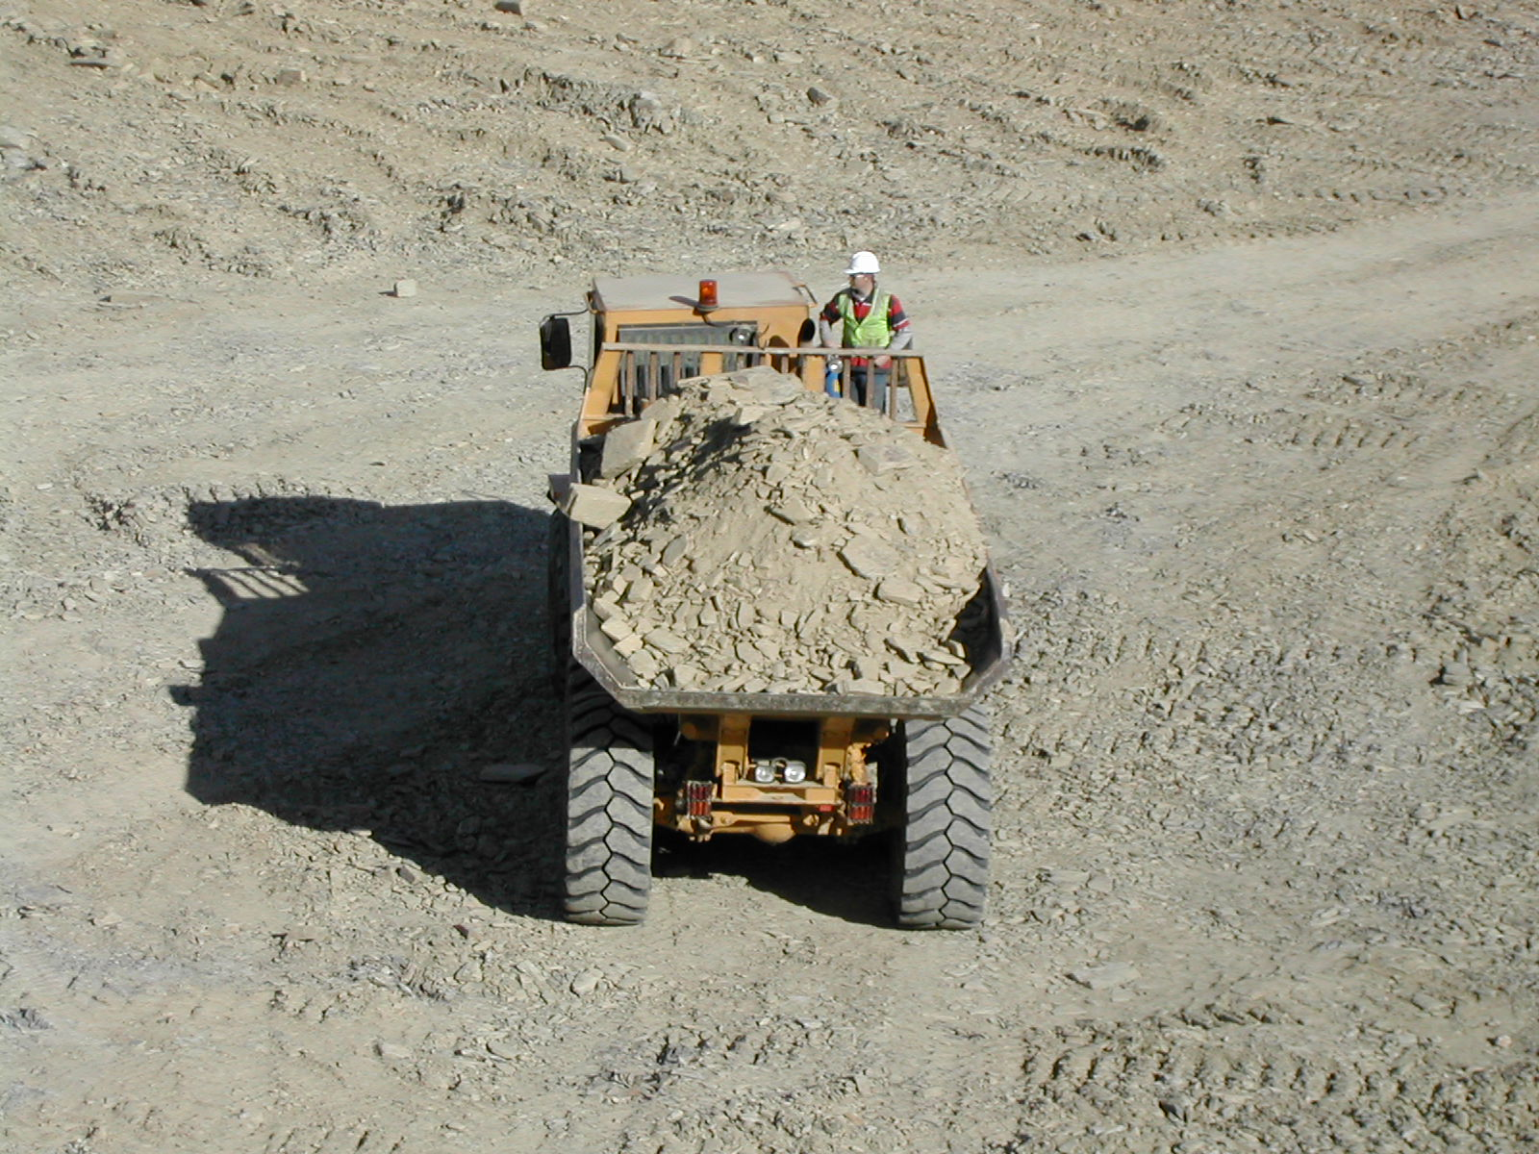

1. Training

One of the requirements of both common law and health and safety legislation is that PCBUs must provide competent and trained staff; where ‘competent’ means both knowledgeable and experienced – and should also mean having the capability and attitude to do the task correctly. A very high number of serious injuries happen to new workers, people undertaking new or different work and sometimes after having a long period of leave.

Training is a means of sharing knowledge and developing skills and attitudes. It is one way of influencing behaviour and improving health and safety.

## What is a training program?

Mine and quarry operators should implement a training program, which will:

* identify what skills, knowledge or competencies a worker should have before starting a job, and analyse the training needed for that job
* develop, maintain or improve employment-related skills, knowledge or competencies of workers
* let trainers determine what skills and knowledge new people have
* design the training for the skills needed
* show how the training will be conducted
* let trainers evaluate the training.

## Training program requirements

**Framework**

A formal training program should include a range of tasks and outcomes and should:

* provide induction training for new people to the industry (and site)
* give additional training for people moved to new work
* train under close personal supervision when starting work, and new tasks
* give skills maintenance training to each person employed at a mine/quarry/extractive industry operation
* require that records of the training of each person be kept.

**Induction training**

Induction training is usually the first introduction to the site. It is usually a formal training session and basic on-the-job training, which can be conducted by a supervisor/manager.

**Job and task performances**

Training should focus on a job or task rather than on an occupation. This will include training in procedures that have been developed to control hazards associated with the task.

**Diagnostic maintenance skills**

For employees involved with equipment and changing work site conditions, training should include techniques for identifying potential malfunctions, hazardous conditions and unsafe work situations.

**Refresher training**

Refresher training should be included in operational training programs, and should include briefing techniques for updating individuals, supervisors, production managers and senior workers on changes in work practices, new equipment operating procedures and changes in the working environment generally.

**Reviews of training schemes**

Site instruction and training programs should be reviewed regularly.

**WHS training in progress.**

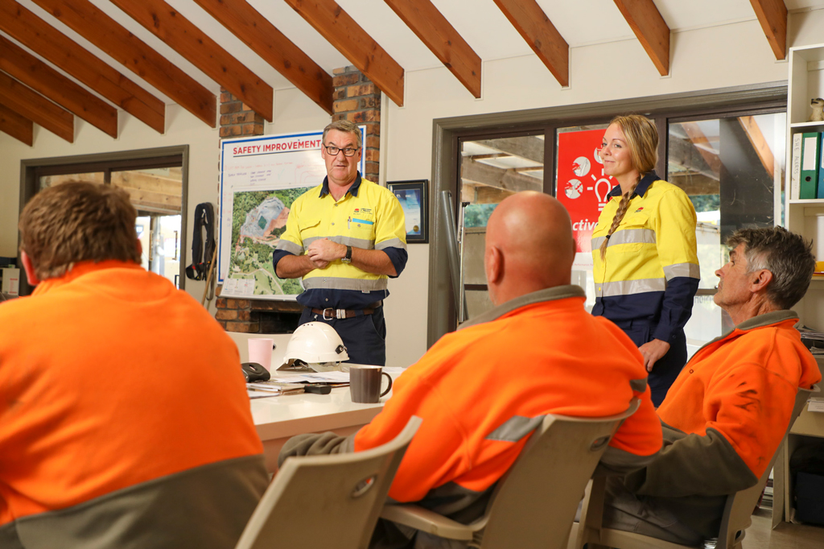

## Types of training

The type of training that each person at the site needs depends on:

* each person’s role and responsibilities at work
* each person’s occupation (e.g. plant and machine operators and people who handle hazardous substances need specific training)
* the hazards identified during an inspection of your workplace
* the type and occurrence of injury and disease at work.

## Health and safety training

At all operations, no matter how large or small, everyone needs training in health and safety matters, this will include:

* the employer, including managers
* the supervisor
* all employees – casual, part-time and full-time
* students on work experience
* new workers
* contractors who work on your site
* the health and safety committee representative
* members of the health and safety committee.

C:\Users\stoopk\Pictures\spotlight.PNG

**Purpose**

The basic aim of health and safety training is to impress the principles of good health, accident and incident prevention and safe behaviour upon employees so that they will apply these principles to their work.

The need for health and safety training at work is continuous. As circumstances at work change, there will always be the need to ask the questions:

1. How does this change affect health and safety?
2. What health and safety instruction and training do I need to provide now?

Typical times when you need to ask these questions are:

* whenever you take on someone new at work – health and safety is an important part of induction training
* whenever you buy new machinery or equipment or new substances such as chemicals
* whenever people’s jobs change
* whenever you change the layout of your work environment
* whenever there are new health and safety regulations, standards or laws that affect your industry
* if there has been an accident, injury or health and safety incident at work.

There is a need to make some decisions such as:

* How much money are you going to spend in training over the next six to 12 months?
* How much time will you give to training?
* What is the most cost-efficient way for you to make this investment?
* to send one employee to the health and safety course and a train-the-trainer course and then schedule time for him/her to train others at work?
* to send a group of people to the training course?
* to arrange for a trainer to come to the mine and deliver training to a group of workers?

## Planning for safety and health training

Training programs are best planned if everyone at work:

* has basic information about the laws and Regulations
* has the opportunity to talk about health and safety concerns
* uses the health and safety skills and knowledge they have
* takes part in a workplace inspection and identifies hazards at work
* takes part in a training needs analysis to find out what training each person needs.

## Training needs analysis

Conducting a health and safety training needs analysis (TNA) will ensure that the people at your site get the type of training they require to perform their tasks.

It will enable you to ensure that the training is relevant to the job and the changing needs of the workplace.

A TNA involves looking at all aspects of work, including the work environment, the actual jobs people do and the skills and knowledge of each person at work. Once this information is collected, then you can start to plan what training your operation needs.

1. Hazardous chemicals and dangerous goods

## Definition

A hazardous chemical is defined by the WHS Regulations as any substance, mixture or article that satisfies the criteria of one or more globally harmonised system of classification and labelling of chemicals (GHS) hazard classes, including a classification in Schedule 6 of the WHS Regulations.

Most substances and mixtures that are dangerous goods under the ADG Code are hazardous chemicals, except those that have only radioactive hazards (class 7 dangerous goods), infectious substances (division 6.2) and most class 9 (miscellaneous) dangerous goods.

Dangerous goods are divided into nine classes according to their dangerous properties

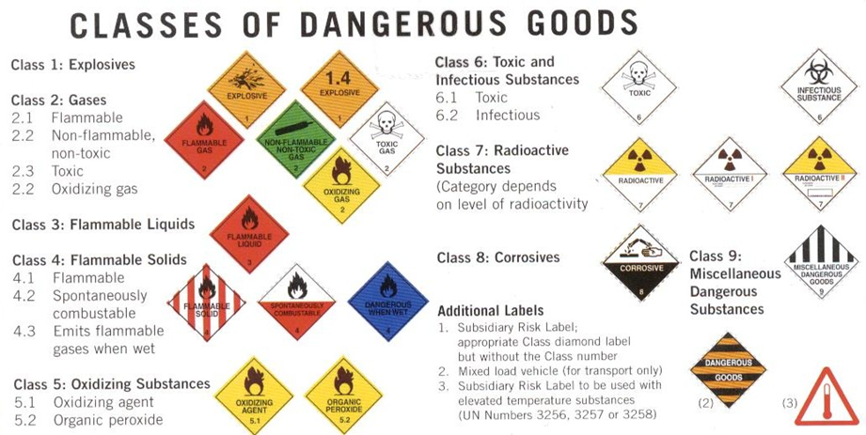

It may be necessary to obtain a licence to store dangerous goods and/or a requirement to placard your site or maintain a detailed manifest, depending on the quantity you intend to store.

## Process to control the use of hazardous chemicals

The code of practice *Managing risks of hazardous chemicals in the workplace* July 2014, published by Safe Work Australia, provides guidance on how to manage the risks associated with hazardous chemicals on a work site. The code applies to:

* substances, mixtures and articles used, handled, generated or stored at the workplace which are defined as hazardous chemicals under the WHS Regulations
* the generation of hazardous chemicals from work processes, for example toxic fumes released during welding.
* C:\Users\stoopk\Pictures\spotlight.PNG

**Note:**

The two principal components of a system to manage hazardous chemicals are:

1. Information provisions – which address the delivery of specific information, such as labels and material safety data sheets (SDS), that the supplier has to provide;
2. Assessment and control provisions – which require employers to identify hazardous chemicals in the workplace, make an assessment of those hazards and then take appropriate control action.

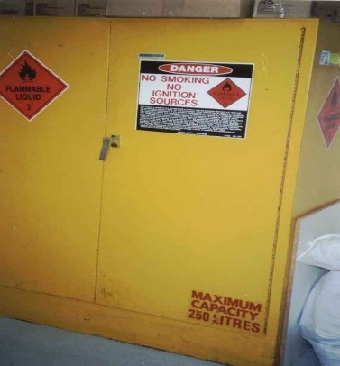**Appropriate storage facilities All containers must be labelled**

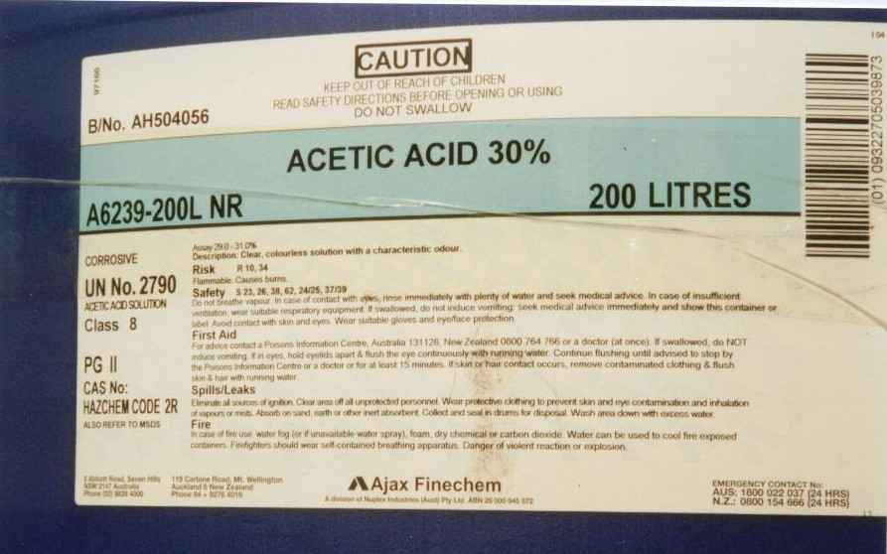

Manufacturers and importers of hazardous chemicals used in workplaces must prepare and make available an SDS for each substance. PCBUs and contractors must obtain and make readily available a SDS for any hazardous chemical used in the workplace and consult with workers who use the hazardous chemicals and may be exposed to it. PCBUs need to keep a register of hazardous chemicals used in the workplace and should always request SDSs for all hazardous chemicals they use.

Any hazardous chemicals stored on site should be labelled in accordance with the requirements of the code of practise *Labelling of workplace hazardous chemicals* September 2015 produced by Safe Work Australia.

While this code applies to hazardous chemicals as defined, it is recommended practice to provide a label for any chemical that is suspected of producing adverse health, safety or environmental effects but has insufficient information generated to allow it to be correctly classified.

PCBU duties:

* Obtain safety data sheets (SDS) from suppliers for all hazardous chemicals used in the workplace.
* Compile a Hazardous Chemical Register.
* Ensure all hazardous chemicals are clearly labelled according to dangerous goods class labels and hazardous chemical codes.
* Ensure all workers exposed to a hazardous chemical receive appropriate training and instruction.
* Decide whether any improvements should be made to machinery or procedures.
* Decide whether any environmental monitoring should be done.
* Check that emergency equipment and procedures are adequate.

Carry out a basic risk assessment by:

* identifying the hazardous chemicals by examining the label looking for words such as caution, poison, hazardous and dangerous goods labels;
* reviewing information from SDS regarding the toxicity and the precautions to reduce risk;
* examine the workplace and work practices asking:
* how often are employees exposed to the substance?
* are there fumes, dust or other airborne contaminants exposed to workers?
* Take steps to prevent or adequately control exposure to hazardous chemicals.

1. Registers

Registers of key records that are maintained as part of the SMS enable easy access to important information. They should support a simple way of reviewing an issue such as preventative maintenance. In Part 2, Templates there is a list of typical registers. Use only what is pertinent to your operation.

1. Explosives control plan

Explosives should be manufactured, handled, stored, conveyed and used in or about mines in a manner that is safe.

The usage, storage, manufacture and conveyance of explosives in or about mines should generally be in accordance with Australian Standards.

**Typical blast area**

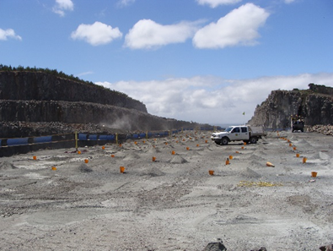

Explosives should be protected from fire, impact, loss, spillage, deterioration, theft and accidental initiation tto minimise the risk to the safety of any person.

Nobody should retain, remove or otherwise dispose of explosives other than in the proper running of the mine. Theft and misuse is treated very seriously.

## People handing explosives

The mine operator should authorise people to use and handle explosives. Workers must hold the appropriate qualification that allows them to perform the task nominated on the license. Workers must also be deemed competent in any site-specific procedures that they are required to work under.

No-one under the age of 18 years should be allowed to handle, charge or fire explosives.

There should be no smoking while handling, charging or using explosives, nor within a distance of 10 metres of explosives, initiating system, or accessories.

## Storing explosives

The storage of explosives, above quantities able to be held under a shotfirers licence, must be in magazines that a compliant with AS 2187 and pursuant to a license to store.

Magazines should be of a construction and in a location that minimises risks of theft, fire and impact, and which minimises the effect of any detonation during storage, and also minimises any adverse impact from storage. The quantity of explosives should be displayed on the door of the magazine or storage area and adequate ventilation provided.

Detonators and explosives should be stored in separate magazines. If explosives and detonators are stored in the same magazine, they should be kept separated by a solid intervening fireproof barrier.

A means of maintaining an accurate record of all incoming, outgoing and current stocks of explosives should be instituted. This may consist of a board, magazine log book, or other means. The theft or loss of explosives or any unaccountable stock shortages of explosives should be reported immediately to an inspector and to police.

## Moving explosives

Explosives when taken from a magazine or supply point for use should be conveyed directly to the workings in a securely covered case or canister or other suitable container in a manner that minimises risks of initiation.

If a vehicle is travelling via a public road it must be licensed in accordance with state Regulations. Workers who transport explosives are also generally required to hold a security clearance issued by the state regulator.

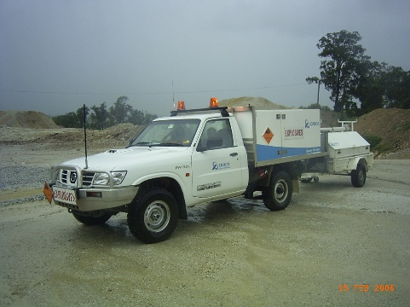**Typical transport vehicle**

## Charging of explosives

Working in close proximity to high walls needs to be managed with a selection of temporary barricades and signs. The charge-up area should also be defined by signs to prevent unauthorised access by vehicles and people.

It is very important to dissipate any electrostatic charges generated while pneumatic charging with explosives. Vehicles being used in a charged area must be incapable of causing pre-ignition of explosive charges through heat or stray current. The use of radio communication equipment at the mine should be strictly controlled to prevent pre-ignition.

## Firing of blasts

No blast should be fired until an exclusion zone has been determined after consultation with the shotfirer and all personnel have been removed from the zone. Documented procedures should exist to confirm that all checks have been completed, including notification to community, removal of people, any traffic management protocols, placement of environmental equipment, confirmation of weather conditions, handover of the site, successful firing and confirmation that misfires do not exist.

Procedures should be developed for times when an electrical or dust storm, of sufficient intensity to be dangerous, appears imminent. The procedures might include:

* all people working in or near an area where explosives are stored or manufactured should be withdrawn to a safe area
* all vehicles conveying explosives should be returned to a safe place until the storm activity has passed
* explosives and detonators which are not yet used should be returned to the magazines.

## Misfires

When a hole is known to have misfired and is left unattended, a barricade or other obstruction with a danger notice should be placed to advertise the misfire and to prevent an inexperienced person interfering with the hazards. All misfires should be managed as per a documented misfire procedure, with controls likely to include, exclusion zone, identification of area, risk based excavation, screening of equipment, location of spotter, controlled firing with confirmed burden or removal of redundant explosive.

1. Traffic management plan

Planning is the first step to ensure work is done safely. A traffic management plan details how the risks associated with plant and vehicle traffic are being managed in a workplace. Plans should be regularly monitored and reviewed to ensure they are effective and account for changes in the workplace. A traffic management consultative team consisting of management, health and safety representatives, safety advisors/officers, workers, contractors and others in the supply chain should be actively involved in planning, developing, monitoring and reviewing traffic management plans.

If you have a large workplace with a high volume of traffic a traffic management plan can help you communicate how you are managing traffic risks in your workplace.

A traffic management plan may include details of:

* the desired flow of pedestrian and vehicle movements
* the expected frequency of interaction of vehicles and pedestrians
* illustrations of the layout of barriers, walkways, signs and general arrangements to warn and guide traffic around, past, or through a work site or temporary hazard
* how short term, mobile work and complex traffic situations will be managed.

A traffic management plan could also set out:

* responsibilities of people managing traffic in the workplace
* responsibilities of people expected to interact with traffic in the workplace
* instructions or procedures for controlling traffic including in an emergency

A traffic management plan should be regularly monitored and reviewed and importantly following an incident to ensure it is effective and takes into account changes at the workplace.

You should ensure workers are familiar with the traffic management plan and you should provide information, instruction and training on its use.

Before mobile plant is used in your workplace you must provide anyone who will use it with the information, training, instruction or supervision necessary to protect them and others from the risks associated with traffic in a workplace.

Workers including contractors who are required to perform duties associated with traffic management at the workplace should be trained to perform those duties. Training should be provided to workers by a competent person.

Responsibilities for health and safety management must be clearly allocated. It is important each worker, contractor, subcontractor, visiting driver and other relevant people clearly understand their role in following safe work practices and taking reasonable care of themselves and others.

Visitors should report to the reception area or site office and be given information on the safety procedures for the workplace before they are allowed into areas where vehicles and powered mobile plant are used.

You must ensure that any information, training and instruction provided, is presented so it is easily understood by workers. This may require providing information and training material in different languages.

## Pedestrians:

The best way to protect pedestrians is to make sure people and vehicles cannot interact. Where powered mobile plant is used at a workplace, you must ensure it does not collide with pedestrians or other powered mobile plant.

This can be achieved by not allowing vehicles in pedestrian spaces or not allowing pedestrians in vehicle operating areas.

However, this may not be reasonably practicable in all workplaces. If people and vehicles cannot be separated you should consider using:

* barriers or guardrails at building entrances and exits to stop pedestrians walking in front of vehicles
* high impact traffic control barriers
* temporary physical barriers to delineate work areas
* separate, clearly marked footpaths or walkways e.g. using lines painted on the ground or different coloured surfacing
* provide clear delineation with signs
* positive communication protocols
* high visibility clothing, exclusion zones around working mobile plant

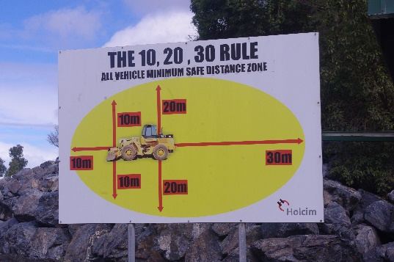**Mobile plant exclusion zones**

## Vehicles routes

Wherever possible vehicle routes at the workplace should consider traffic flowing in a single direction. Where this is not achievable a risk based approach should be undertaken to determine the best way in which intersections, parking areas, loading bays, stockpile locations and emergency areas (ramps, parking etc) can be designed and located to minimise vehicle interactions to the lowest practicable level. This information is best detailed on a traffic management plan that is displayed in a prominent location and a copy given to persons as they are inducted.

## Road design:

Should:

* be constructed with suitable material to provide firm surfaces, adequate drainage and safe profiles to allow safe vehicle movements
* be clearly signposted including speed limits and UHF call notifications
* where appropriate, have edge protection and road markings (e.g. sealed roads) or delineators showing the right of way
* have speed limits and speed control measures specific to site conditions and the types of vehicles using the route
* have adequate rock fall protection measures (e.g. a catch ditch, catch bench or suitable barrier)
* be clearly delineated in the hours of darkness by using lighting reflective marker pegs or similar devices or have suitable access restrictions to hazards (e.g. ponds or other water filled hazards or steep drop-offs)
* allow for back break of the bench crest during the life of the road. The amount of back break will depend on geotechnical characteristics of the bench
* minimise the need for reversing with one-way systems and turning points
* accommodate the turning circles of vehicles.

Also consider:

* access to the site including weight restrictions on bridges and narrow roads
* height limitations for traversing under overhead structures
* where distribution points will be (e.g. processing areas, weighbridge location, workshop access, load covering areas, loading areas, points of sale to the public)
* impacts of land adjacent to the road.

Where practicable, road design should avoid:

* office facilities and light vehicle parking areas
* unstable areas
* hazards such as excavations, ponds, structures, fuel or chemical storage areas, underground workings or voids and overhead power lines
* steep gradients and tight bends
* one-lane two-way routes.

You may need to engage a specialist traffic engineer for complex traffic flows, especially at sites with large processing operations.

## Parking areas

Parking may be needed for workers, visitors, trucks and other vehicles used in the workplace. Consider setting out the workplace so parking areas:

* are located away from busy work areas and traffic routes
* have walkways leading to and from parking areas which are separated from vehicles or vehicle routes e.g. use physical controls like barriers or bollards to prevent vehicles from crossing into walking areas
* are clearly marked and sign-posted, well-lit and unobstructed.

## Signs and road markings

* Clear road markings like reflective paint and signs should be used to alert pedestrians and vehicle operators to traffic hazards in the workplace.
* Signs should be provided to indicate exclusion and safety zones, parking areas, speed limits, vehicle crossings and hazards like blind corners, steep gradients and where particular pieces of equipment can be used.
* Signs and road markings should be regularly checked and maintained so they can be easily seen.

## Communication

Positive communication methods are an integral part of managing traffic movements. Sites need to consider as a minimum the following controls:

* Dedicated radio channels that are clearly signposted
* Fitting all equipment with radio devices
* Positive communications where operators provide a return verbal response
* Having clear guidance and rules detailing how, if ever, mobile phones are able to be used
* Sign posting call points (also known as hold points) requiring the announcement of vehicle entry
* Supervision of the application of communication rules.

1. Principal hazard management plans

There are hazards associated with mining operations that, although having a low likelihood of occurrence, have the potential for multiple deaths in a single incident or a series of recurring incidents. This category of hazards is known as a principal hazard.

Mine operators are required to identify principal hazards associated with their mining operations and to develop a plan that documents how the risks to the health and safety of persons arising from the principal hazard will be eliminated or minimised so far as is reasonably practicable.

If a principal hazard does not exist at the mine then the PHMP for that hazard is not required.

Principal Control Plans

Safety Management System

Principal Hazard Management Plans

Manage other hazards

Ground or strata instability

Inundation and inrush

Mine shafts and winding operations

Roads and other vehicle operating areas

Air quality, dust and other airborne contaminants

Fire or explosion

Gas outbursts

Spontaneous combustion

Subsidence

Any other hazard identified by the mine operator that meets the definition of a principal mining hazard

Site specific arising from risk assessments

Mechanical Engineering

Electrical Engineering

Explosives

Health

Emergency response

**PHMP should include:**

* the principal hazard identified
* a risk based approach to reviewing hazards
* agreed control methods for managing the identified risks
* arrangements for reviewing and revising agreed control methods,
* a record of any revisions of PHMP and associated risk assessments

The following list provides information that should be considered when PHMP are being developed; *(the list is not exhaustive)*

### Ground or strata failure

* Geological structure and rock properties
* Local hydrogeological environment (ground and surface water, drainage patterns)
* Geotechnical attributes (bedding, jointing, faulting, intrusions, cavities)
* Pit design and layout (face direction, face height, bench width)
* Effects of blasting on structure (design, back break)
* Matching machinery (ability to scale, compatible with bench widths)
* Procedures to inspect and monitor ground or strata instability
* Procedures to inspect and monitor ground or strata instability
* Proposed rehabilitation methodology and how it relates to ground and strata stability
* Details of any proposed ground support methods or exclusion zones
* Filling requirements for mined areas and the material to be used as fill

### Inundation or inrush of any substance

* Identify potential sources of inrush (collapsing stockpiles, adjoining excavations, tailings dam failure).
* Identify potential sources of inundation (extreme weather, overflow or failure of levies, river banks or dam structures).
* The location, design and construction of dams, lagoons, tailings dams, emplacement areas and any other bodies of water that could enter the mine in extreme weather conditions.
* Any potential for the accumulation of water, rock or other substances that could liquefy or flow into workings.
* The nature and magnitude of all sources.
* The worst possible health and safety consequences of each potential source.

### Mine shafts and winding operations

Not applicable to open cut

### Roads and other vehicle operating areas

* Measures to control the design, layout, operation, construction and maintenance of all roads and other vehicle operating areas
* Interaction between mobile vehicles and public traffic
* Interaction between mobile plant and pedestrians
* Interaction between multiple vehicles and different types of vehicles (HV and LV)
* Interaction between mobile plant and fixed structures
* Characteristics of road design (curvature, gradient, surface, barriers, width, drainage, stopping distances, speeds, line of sight, camber, safety berms, signs, intersections, lighting)
* Mobile plant characteristics, including stopping distances, manoeuvrability, operating speeds, driver position, line of sight and remote-control equipment
* Impact of mine design, including banks and steep drops adjacent to vehicle operating areas
* Traffic controls (communication systems, direction, parking, volume, speed, authorisation, loading, training, refuelling)

*(note: traffic controls are detailed in section 19 ‘Traffic Management Plan’’)*

### Air quality or dust or other airborne contaminants

* The types of dust and other contaminants likely to be in the air from both natural and introduced sources that may result in a risk to health and safety on exposure
* Reference to exposure standards for the substance or mixture
* Details of airborne monitoring to determine the airborne concentration in relation to exposure standards
* Contaminants could include total dust, respirable dust, silica content, naturally occurring asbestos, diesel particulates
* Risks associated with extremes of either or both temperature and moisture content of air
* Reference to any potential hazardous atmospheres on site, including oxygen deficient atmospheres, higher fire risk due to the presence of oxygen, combustible dust presence or concentration of flammable gas, vapour, mist or fumes
* Ignition sources in hazardous atmospheres

*(note: health controls are detailed in section 7 ‘Health Control Plan’’)*

### Fire or explosion

* Potential sources of fire
* Potential sources of flammable, combustive and explosive materials, both natural and introduced, including gas, dust, fuels, solvents and timber.
* Potential sources of ignition, fire or explosion, including equipment, electricity, static electricity, spontaneous combustion, lightening, hot work and other practices
* Details of the type and location of systems for the prevention, early detection and suppression of fire
* Details of training and qualifications of people on site with respect to fire suppression
* Arrangements for the management and control of the transport and storage of combustible liquids

### Gas outbursts:

* Limited application to the extractive sector of the mining industry, however could include
* Potential for gas release into a working area from both natural and introduced sources
* Potential for accumulation of gases in existing and abandoned areas of a mine
* The nature of the gas that could be released,

### Spontaneous combustion

* Limited application to the extractive sector of the mining industry, however if suspected obtain professional advice.

### Subsidence

* Limited application to the extractive sector of the mining industry, however if suspected obtain professional advice
* Most hazards associated with subsidence have been covered in the ground or strata instability section.

1. Mine planning

Before any excavation commences, an assessment of the site ground conditions should be undertaken by a competent person to determine all factors likely to affect the stability of the ground and the limitations that should be imposed on the excavation site design. This should be documented.

The mine should have a well-considered and practical mine plan. The assessment should be reviewed and revised where necessary when a material change has occurred in the ground conditions or the excavation methods. Effective ground control relies on geotechnical information obtained at different stages of the life of the site including planning and design, implementation of the design and through day-to-day operations such as surveying, installation, maintenance and inspections.

Following assessment of ground conditions, a design should be prepared setting out the measures to control ground instability. Where an existing design has already been proved, it may be used as the basis for the design of a new excavation, if the ground conditions at both sites are not significantly different. This requires ongoing assessment of the ground conditions, as incremental change can occur over time resulting in different ground conditions from those originally excavated.

During planning and design, there is usually a relative lack of data available when the slope design is first developed. It is therefore essential geotechnical information obtained during operations is consolidated with information in the geotechnical model and continually used to assess the suitability of the slope design in relation to ground stability and adjust site parameters if required.

Implementing the design typically involves considering suitable ground control strategies, such as minimising unnecessary damage to slopes during blasting, excavation control and scaling, and installation of ground support and reinforcement.

**Slope design – inter-ramp and overall slope details.**

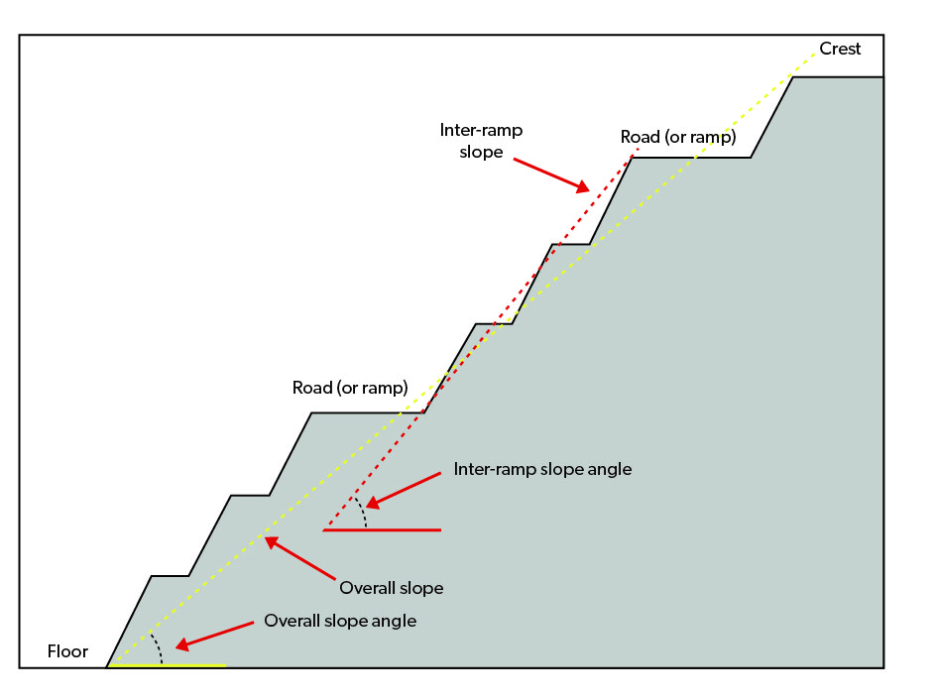

## Excavation rules

Excavation rules should be refreshed regularly and include:

* the manner in which excavation activities should be carried out, specifying the type and reach of excavators
* the physical dimensions of the excavation including slope, height of faces, width of benches, position of catch-berms and gradient, position and protection of access ramps
* the way in which material should be removed from the excavation
* the sequence in which material should be removed
* maintenance of faces including scaling of crest lines etc
* the nature and frequency of supervision required
* response to defects.

These rules are essential for the management of excavations. They are practical measures required to keep excavations and the people working in and around them safe.

**Pit design should always include:**

* suitable slope angles
* suitable bench widths and heights
* bench widths a minimum of half the face height, and not less than 3.5 m, and/or 3.5 times the width of the widest HME for dual lane access and twice the width of the widest HME for single access benches
* face heights suitable for the site conditions and excavation method
* faces that do not exceed the reach of the excavator
* faces regularly scaled to control the risk of rock falls
* faces, at quarries, and working benches in alluvial mines, that have not been undermined.

You should consider whether a geotechnical assessment is needed.

As a guide:

* Simple operations (e.g. shallow depth, soft material with faces less than 3.5 m, or competent rock with faces less than 15 m) a competent person should determine if the face design is safe, adequate benching is in place, or arrange for a geotechnical assessment. Assessments should be in writing, dated and signed with a review period established.
* Complex operations (e.g. individual faces exceeding 15 m, overall excavation depth exceeding 30 m, fractured rock, disturbed geological structure) will require a geotechnical assessment by a competent person.

## Working bench widths

To determine working bench widths, consider the type of equipment and the method of mining or quarrying. Ensure there is enough room to allow for the:

* implementation of exclusion zones in areas of unsafe ground conditions that may occur
* bench access to be located a suitable distance away from the batter face
* excavating mobile plant to work
* correct positioning of trucks being loaded
* safe queuing of trucks while waiting to be loaded.

People should not be allowed to work near or under hazardous batters or benches. Unsafe ground conditions should be promptly actioned and remediated or treated as an exclusion zone.

## Mobile plant working on faces

Faces that have potential for instability should be worked within the reach height of the equipment used, whether they are working in sand or hard rock. Typically, wheel loaders can reach 6-8 m and excavators 9-12 m. Larger mining shovels (120 tonne or more) are capable of reaching 18-20 m depending on how they are used. If mobile plant is at risk of being engulfed in a face collapse, a trench or rock trap should be used to maintain a safe operating distance and to ensure a void to catch potential rock fall volumes has been dug.

Good blasting practice will result in muck piles that can extend the reach of the excavating equipment.

**When working the face, the face height should not exceed the reach of the loader being used.**

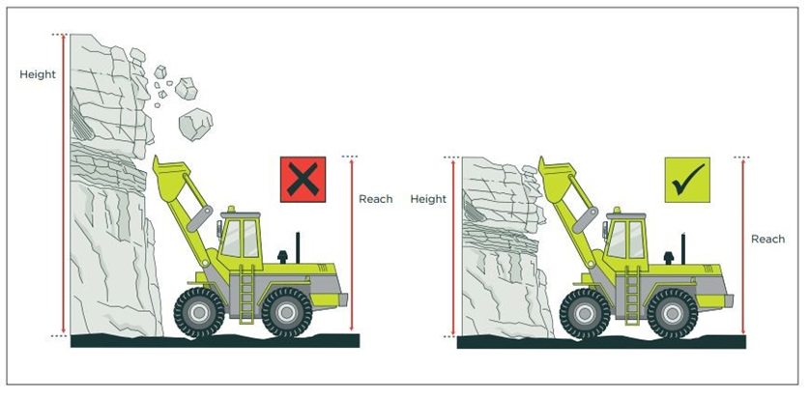

**When working the face, the face height should not exceed the reach of the excavator being used.**

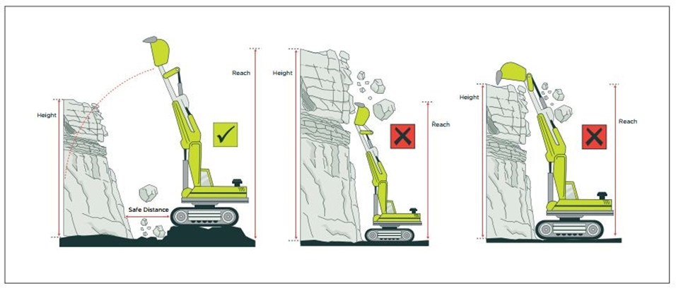

**Face height can be extended where a methodology of controlling the hazards on the face is readily available e.g. excavator sitting on a muck pile, thus increasing the scaling height or excavator scaling from above, or using chains.**

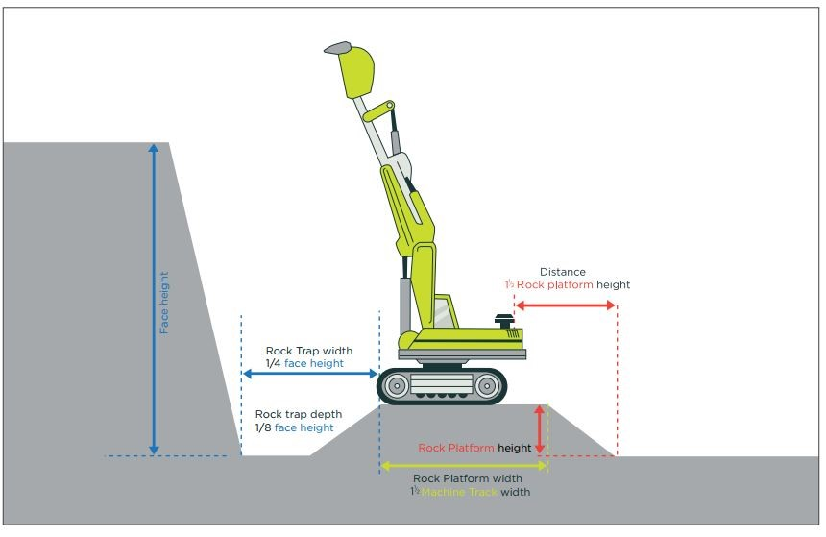

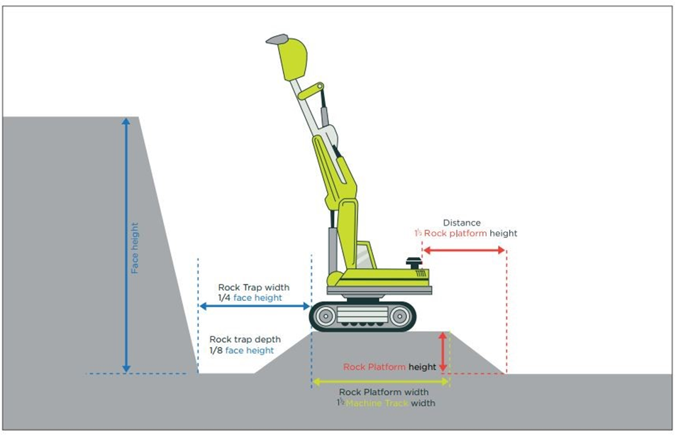

1. Audit and review

Get your SMS underway before giving this program any attention. One year after you’ve had a SMS in operation have a look at this program.

A good review can start with two basic questions asked honestly:

1. what went really well over the past 12 months with our safety / health performance?

2. in what areas could we do better?

These questions can be asked informally so they have immediate appeal. However, just as a structured (formal) workplace inspection can detect hazards that are not so obvious, so too a structured review will help identify concerns that might otherwise go unnoticed.

The kit has a document titled Mine Safety Management Plan Assessment, which can be used to conduct your structured review.

As time goes by and your experience and level of comfort with a SMS increases you might be wise to engage a fresh set of eyes to have a look for any strengths, gaps or improvement areas.

1. SafeWork NSW How to manage work health and safety risks
2. SafeWork NSW How to manage work health and safety risks